CILT Philippines Report November 2020
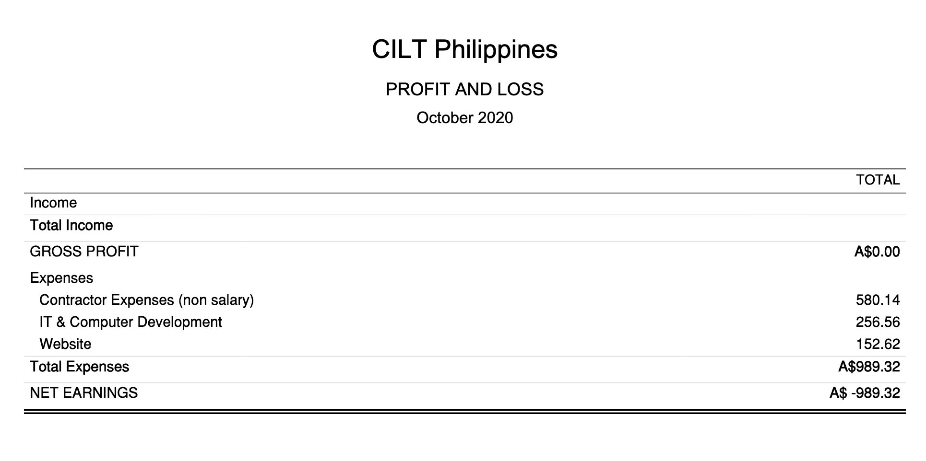
Philippines Activities
Established the new National (Australian/Philippines Section Committee) for the Philippines, consists of:
- Marjorie Rola – National Chair
- Brian Artates – Secretariat – Governance and Finance
- Janine Mao Tayo – Event Management and Finance Support
- Janine Mao Tayo - WiLAT
- Paula Borja – Administrative Support
- Joshua Suarez – Next Gen
- Karyn Welsh – CEO (Mentor)
Issues:
- Brian Artares’ and Paula Borja households have had COVID19 positive cases.
- Brian and Paula have also been impacted by the recent Typhoon with lost of power and Internet due to flooding.
- Given the COVID19 issues the team have focussed on putting a number Webinars together as the Philippine activities until face to face events are again allowed to occur. The Philippines team have adjusted the original implementation plan as a result of COVID19.
- The first Webinar “The Critical Role of Supply Chain Management During the Pandemic” was held Friday 31 July 2020 at 6:30p (4:30p Philippines). We had 58 registered and 28 attend this event. This next event scheduled for the 22 September had 39 registered attendees.
- The expenditure planned for this financial year (up to the end of September 2020) had relied on two further instalments at the end July of November 2020. This was deferred as a result of COVID19 and IMC requesting it be deferred. The Trustees asked to defer the project funding until the new financial year (commencing 1 October 2020).
- Philippines have employed a very part-time (15 hours) employee Paula Gallian as the Administrative Support. Philippine strategy is to develop the social media and website so as to demonstrate to the Philippines that we add value to the Transport and Logistics Industry. All online webinars are being put on these platforms for industry participation and the team are circulating these amongst their network.
- Ian Kano the Implementation Manager appointed CILT International caused several set backs and delayed website development and Chapter marketing. This person is no longer part of CILT
- This person tried to hold CILT Philippines to ransom with the website. Australia stepped in and with assistance with their IT company successfully moved the website into another domain and we are now working through branding alignment according to the guidelines.
- Social media presence has been their focus whilst funds are limited. Targeted direct marketing could be achieved even on a limited basis with the anticipated follow-up instalments from CILT International.
- Focus will be on driving Membership in 2021
- The Philippines have eight financial members.
Funds:
Opening Balance:
- $6047.81AUD - Grant Funds Deposited by CILT International

Expenses Paid:
Administrative Support Wages:

- $112.28 AUD (Feb/Mar)
- $364.11 AUD (Mar/Apr)
- $290.00 AUD (May)
- $534.46 AUD (June)
- $689.71 AUD (July)
- $285.85 AUD (August 1)
- $282.57 AUD (August 2)
- $281.85 AUD (Sept 9)
- $290.24 AUD (Oct 2)
- $290.07 AUD (Oct 22)
- $287.97 AUD (Nov 5)
- $285.61 AUD (Nov 19)
- Total: $3994.72

IT Philippines
- Ian Kano Expenses – Website Development
- Web Hosting - $85.28AUD
- Office 365 Subscription - $97.20AUD
- Google Suite Subscription - $170.10AUD
- Web Development - $486.00AUD
- IT Costs - $256.56
Total: $1095.14AUD Paid

Website Transfer from I Kano (Fuzzy Logistics):
- $97.95 – Annual Hosting
- $69.93 – Registration of new Domain Name (cilt.org.ph)
Total: $167.88 AUD Paid
Income:
- $68.17 – Membership (MILT)
- $70.50 – Membership (MILT)
- -$80.27 – Membership (CMILT) (Refunded)
- $70.50 – Membership(MILT)
- $41.28 – Membership(Student)
- $70.50 – Membership(MILT)
- $70.50 – Membership(MILT)
- $70.50 – Membership(MILT)
Total: $381.68

Current Account Balance 20/11/2020:
$1336.23 AUD

There are further expenses that will require reimbursement. These expenses have been paid by myself in the establishment of the website and its applications. I am prepared to wait until memberships roll in.

Accrued
There are further expenses that will require reimbursement in time. These expenses have been paid by myself in the establishment of the website and its applications. I am prepared to wait until memberships roll in and the Philippines are sustainable.

Karyn Welsh's Expenses -
  - Plugin Multipurpose Theme for Wordpress - $75.80AUD
  - License Key for Plugin Application for Database PmPro - $459.45AUD
  - Total: $535.25AUD

We have appointed a committee members to the role of WiLAT and Next Gen and they sit on Australia’s WiLAT and Next Gen Committee. WiLAT have their committee meeting regularly now and their second event will be held in December. Next Gen will be our focus once the new WiLAT committee is solidly grounded.

In 2021 Education will also be of focus but the Committee are happy to continue driving membership at the moment as it is all a little overwhelming given they are also dealing with COVID and Typhoon issues to.

