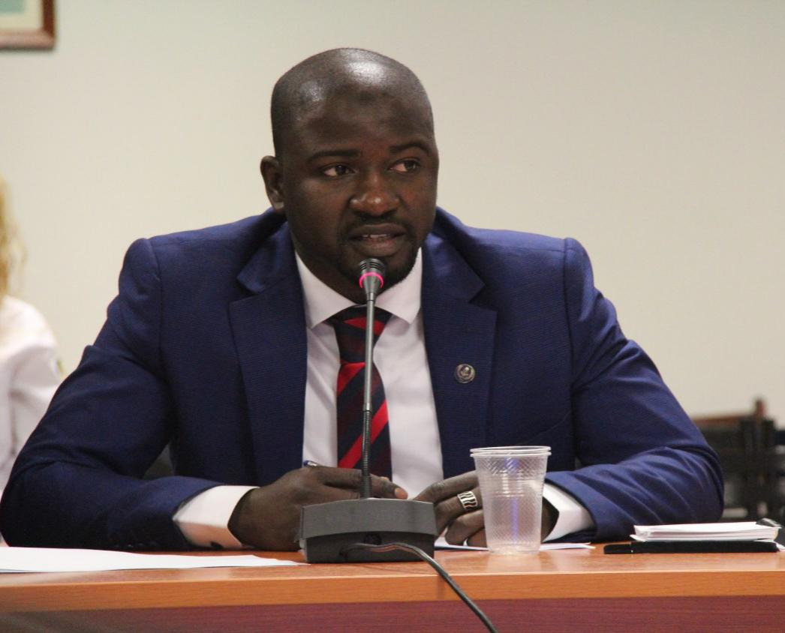
Usman Shuaibu is 35, born in Sokoto in the North Western Nigeria, joined the Chartered Institute of Logistics and Transport in 2015 as an Affiliate Member of CILT Nigeria. His focus was on professional development and hone leadership skills. In June 2016, he became the Chairman of Young Professionals Forum tasked with designing and implementing targeted programs aimed harnessing potentials of young members. Mr. Shuaibu led his team to revive CILT Young Professionals Nigeria and brought the group in the limelight of CILT Activities.
In May 2016, CILT International appointed him the Regional Ambassador for Africa, where he created an inclusive team (Committee) of Africa leads to share current best practices with in a coordinated fashion. The committee successful hosted YP Streams in Abuja, Harare and Accra progressing well.
Before joining the CILT, Mr. Shuaibu gained professional experience in supply chain management within the maritime industry (Nigerian Maritime Administration and Safety Agency- NIMASA).
Mr. Shuaibu is an Educationist from Usman Danfodiyo University (Sokoto) and holds a master degree in International Business at the Southern Cross University, Australia, CILT international Advanced Diploma in Transport and Logistics, CELOTE, Nigeria and Master of Science in Maritime Affairs (Shipping Management and Logistics) at World Maritime University, Sweden. During his master studies, Mr. Shuaibu won the Kalmar Award for Individual Performance and services to fellow students. Mr. Shuaibu group took third position on Intelligent Hunt 5 held in OSLO, Norway: DIGITALIZATION OF EUROPEAN TRANSPORT CORRIDORS. CASE STUDY: OPTIMIZATION OF THE SHORTSEA IT-ES-IT CORRIDOR”.
Mr. Shuaibu is the founder of YoungShip Nigeria a platform for building next generation of maritime Leaders and recently is involved in establishing WMU Regional Alumni Africa scheduled to be launch June 10, Malmo, Sweden. Further key competencies include project management and intercultural skills.
Deliverables
My humble multidisciplinary background and experience have prepare me to lead and coordinate to Next Generation as the Global Convenor. Under my leadership, NG/YP shall be more organised and cohesive to build and sustain past efforts of my predecessors, delivering new value preposition to actualise common goal and drive NG to a new paradigm. My team and the CILT International will work to design new communication channels leveraging on technology best appealing members. NG will find a conducive platform to advocate, promotes and display innovates new ideas.

