_
COUNTRY: CILT ZAMBIA
URL: http://ciltzambia.org.zm/
DATE AUDITED: 17 October 2018

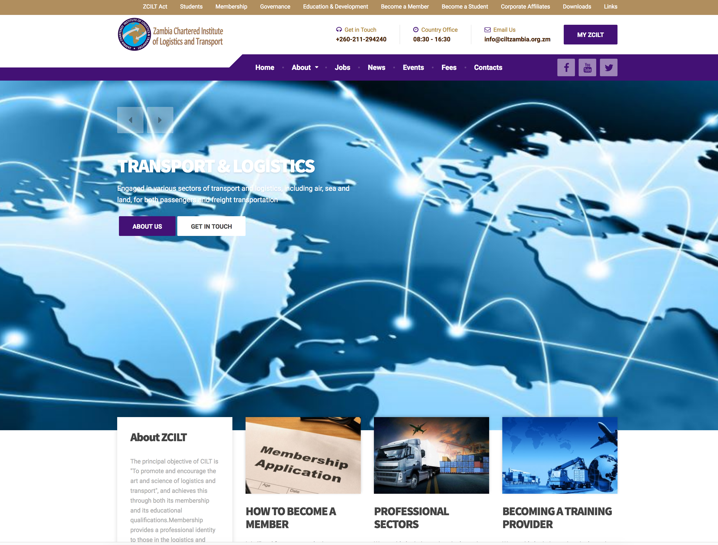

1. CREATING A JOURNEY

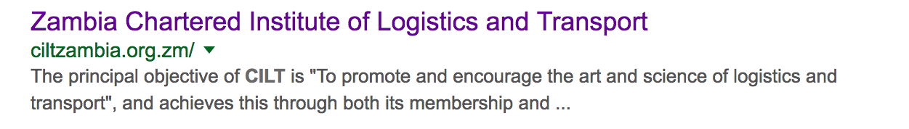

What was checked? | Action required
Search: The meta titles and descriptions do not appear to have been optimised for Google | Optimise page titles and descriptions
Business page: There isn’t a Google Business page available for this location. | Create Google Business page to help boost SEO and to allow users to easily locate and find you.
Https present: None | https:// Website should have an SSL certificate (this will make a green padlock appear)

2. BRAND COMPLIANCE

What was checked? | Action required
Logo: Incorrect logo is used. | Please remove and update and refer to the brand guidelines for guidance.
Photography: Too stock, transport / logistics-based. | The website would benefit from having more positive images that include people. Please refer to the brand guidelines for guidance.
Tone of voice: The style of language used doesn’t feel inclusive, positive or indicative of what CILT does with statements like: it is illegal; we provide logistic services; | Please refer to the brand guidelines and look to soften the copy
Colour: The correct brand colours have been used. | Please use the correct colours as highlighted in the brand guidelines. Just a tick?
Font: Incorrect web font has been used. | Please refer to the brand guidelines for guidance.
Link back to CILT International: No apparent link back to the main website: http://ciltinternational.org/ | Please add in links back to the main, international the main website: http://ciltinternational.org/

3. USER INTERFACE DESIGN

What was checked? | Action required
Homepage proposition: Currently: “Engaged in various sectors of transport and logistics, including air, sea and land, for both passengers and freight transportation “ | Change text. As per the imagery, the key proposition for the website is too, transport / logistics-based and could sound more like a logistics company than an organisation that helps people progress in their careers.
Design: The design is quite clean, clear, and simple. | Would benefit from being more ‘on brand’ as per the points above and with updated photography.
Typography: If the correct font has been used, the typography is ok. | Would benefit from a few less font sizes.
Favicon: An incorrect favicon has been used. | Please use the graphic icon as per http://ciltinternational.org/
Feedback: Button feedback was ok | The website would benefit from better feedback on mouse-overs and clicks so users are aware there is an action to take.
Text within images: This is poor practice for accessibility reasons for people using screen readers but also for Google and SEO purposes. | Please remove text from images and have as html / text.
Accessibility: Text is not legible over the images due to poor contrast | Change contrast or images
Responsive: This website is responsive to mobile devices. | However, the navigation provides a poor user experience and should be made more mobile-friendly.

4. CONTENT AND INFORMATION ARCHITECTURE

What was checked? | Action required
Country selector iframe: Missing | Please add to the top of the website. See http://ciltinternational.org/ and refer to the brand guidelines.
Navigation: Two levels of main navigation have been used. Arguably the priority content for users is smaller and less noticeable in the gold band. The way content has been grouped is somewhat confusing and doesn’t provide a smooth or clear user-centered experience. | Suggest navigation is condensed and rationalised under fewer labels.
Find membership details: There was a dedicated area for membership but no content present. | Add / create new content for this area ASAP.
Broken links: There are a number of broken links across the website, or dead-end links. | Suggest using a free link checker. Like this http://www.brokenlinkcheck.com/ or similar.
WiLAT and YP check: There was an area called students but no clear content for WiLAT or YPs | Add / create new content for this area ASAP.
Quality of content: This varies across the website with a large number of blank pages such as About, Vision and Mission, Links being presented as live. | Suggest pages without content are hidden or new content is created ASAP.
Contact details: Easily accessible | N/A 
Contact details: Easily accessible | N/A
News: There is a news section but there don’t appear to be any current stories. | Please hide / remove this section if there isn’t any capacity to create content. Or add stories ASAP.
General feedback from customer by email: “Thank you for the link. Though it's extremely unhelpful. Full of empty pages. Lacks everything someone needs to know.” | Take on board and review.

5. SOCIAL MEDIA
What was checked? | Action required
Social media links: Links currently go to the main social media websites ie Facebook.com not a dedicated country website. | Please refer to the brand guidelines for guidance.
LinkedIn account: Unable to locate from website | Consider capacity and whether an account should be created. Please refer to the brand guidelines for guidance.
Facebook account: Unable to locate from website. Link found: https://www.facebook.com/ciltzambia/  Likes: 1,054 people like this page.  Last updated: December 2017 | Use correct avatar and update the banner. Please refer to the brand guidelines for guidance.  Consider capacity and whether an account should be retired given the period of inactivity. Assess whether this is due to capacity or training issues.  Content that was posted previously had quite a few likes but varied in quality.
Twitter account: Unable to locate from website. Link found: https://twitter.com/ciltzimbabwe?lang=en  Followers: 96 people  Last updated: February 2018 | Consider capacity and whether an account should be retired given the period of inactivity. Assess whether this is due to capacity or training issues.

