COUNTRY: WILAT
URL: http://www.wilat.org/
DATE AUDITED: 20 September

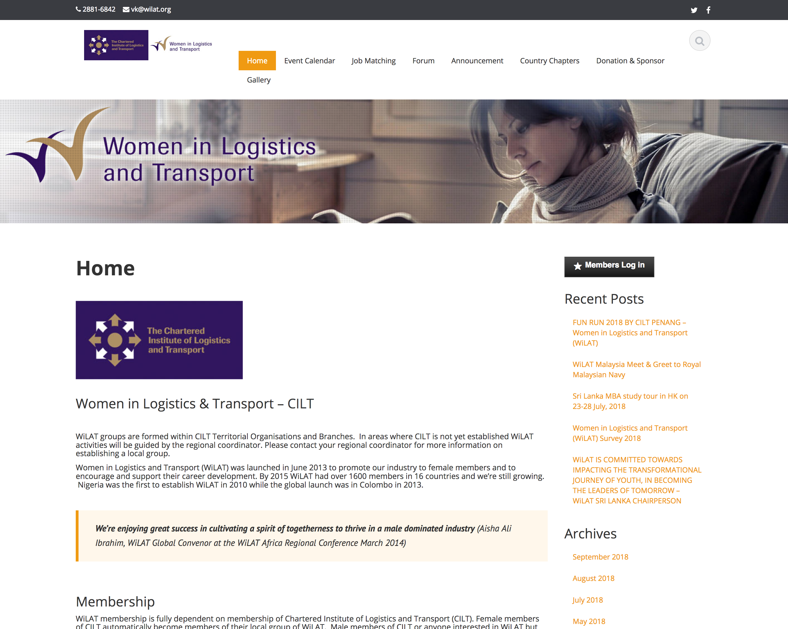

1. CREATING A JOURNEY

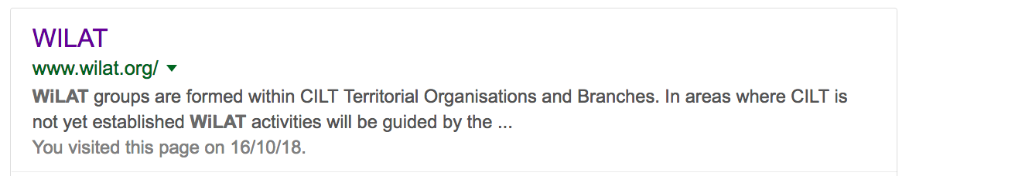

What was checked? | Action required
Search: The meta titles and descriptions do not appear to have been optimised for Google. | Optimise page titles and descriptions
Business page: N/A | N/A
Https present: None. | https:// Website should have an SSL certificate (this will make a green padlock appear).

2. BRAND COMPLIANCE

What was checked? | Action required
Logo: Correct logos have been used but the relationship is skewed. | The WILAT logo is repeated and larger than the CILT logo. When at the top both logos are a little on the small side for legibility  Suggest using the logo without the purple background to help harmonise the website design.
Photography: Whilst the photography is very authentic and people based, it would benefit from some more images rather than the same ones repeated across the site and this could include a more diverse range of people | Consider using some of the better quality images captured from WiLAT events across the world to show diversity and authenticity
Tone of voice: The style of language used initially in the meta description doesn’t feel overly positive but this does improve as you move through the website. | Consider using fewer bullets and making the content into full sentences or grouping content into chunks with clear subheadings.
Colour: The correct brand colours have been used. | N/A 
Font: Incorrect web font has been used. | Please refer to the brand guidelines for guidance.
Link back to CILT international: No apparent link back to the main website: http://ciltinternational.org/ | Please add in links back to the main, international the main website: http://ciltinternational.org/

3. USER INTERFACE DESIGN

What was checked? | Action required
Homepage proposition: The proposition isn’t currently correct and could be more succinct. CILT has WiLAT groups and branches all over the world. It is unclear how there can be WiLAT groups without CILT membership (as eluded to further down). | Consider the balance of the copy as WiLAT is part of CILT, not the other way around.
Design: The design is very simple, and clear. However, the navigation is too long and wraps. | The homepage would benefit from prioritising key content rather than such a long piece of scrolling copy.
Typography: All good. | N/A
Favicon: Correct has been used. | N/A
Feedback: Button feedback OK. | N/A
Text within images: Not a problem. | N/A
Accessibility: No problems | N/A
Responsive: The website is responsive | N/A
4. CONTENT AND INFORMATION ARCHITECTURE
What was checked? | Action required
Country selector Iframe: N/A | N/A
Navigation: The navigation is clear and easy to follow but some of the content is either missing or under construction such as the Events and Announcement pages and the gallery pages appear to be blog posts, rather than a traditional ‘gallery’ | Remove / hide pages that are not being used / in operation as this creates a poor user experience.  Also donors and sponsors should not have such a prominent navigation item, these should be under something like how we’re funded or in the footer as this doesn’t feel appropriate.
Find membership details: There isn’t a clear page for membership. How do people become members of CILT? There is some copy on the homepage but no further information | Create a page / content that clearly states how to become a member of CILT and how WiLAT fits into this as a special interest group
Broken links: There are a number of broken links across the website, or dead-end links, such as the downloads section. | Suggest using a free link checker. Like this http://www.brokenlinkcheck.com/ or similar
WiLAT and YP check: N/A | N/A
Quality of content: This varies across the website. | Due to pages having content missing and some poor quality blog posts, the website would benefit from a re-write and exploring the information architecture and how fit-for-purpose this is from a user perspective.
Contact details: Easily accessible. | The number should have an international dial code. Suggest a nicer email address, like hello@ or joinwilat@
News: There is a news section but there don’t appear to be any current stories. | Consider whether there is capacity to add fresh content like news.

5. SOCIAL MEDIA
What was checked? | Action required
Social media links: No links out to social media accounts on the current website. | Please refer to the brand guidelines for guidance.
LinkedIn account: Unable to locate from website. Links found: there are a few country-based sites none of which appear to be overly well maintained, and carrying incorrect branding such as:  https://www.linkedin.com/in/wilat-nigeria-450aa692/?originalSubdomain=ng  https://www.linkedin.com/in/wilat-sri-lanka-77335686/?originalSubdomain=lk  https://www.linkedin.com/in/wilat-sri-lanka-77335686/?originalSubdomain=lk  Likes:  Last updated: | Consider capacity and whether all country / branch accounts should be retired given the period of inactivity. Assess whether this is due to capacity or training issues.
Facebook account: Unable to locate from website. Links found: there are a few country-based sites none of which appear to be overly well maintained, and carry incorrect branding such as;  https://www.facebook.com/WiLatSG/  https://www.facebook.com/WiLAT-SL-Women-in-Logistics-and-Transport-1440767162893953/  https://www.facebook.com/Women-In-Logistics-And-Transport-120249715353432/  Likes:  Last updated: | Consider capacity and whether all country / branch accounts should be retired given the period of inactivity. Assess whether this is due to capacity or training issues.
Twitter account: Unable to locate from website or search.  Link found: there are a few country-based sites none of which appear to be overly well maintained, and carry incorrect branding such as;  https://twitter.com/wilatsa  https://twitter.com/WiLAT_SL?lang=en  Followers: 56  Last updated: 18 September | Consider capacity and whether all WiLAT SA accounts should be retired given the period of inactivity. Assess whether this is due to capacity or training issues.  WiLAT SL is updating it’s feed on a regular basis but this should really be part of the CILT SL feed and not separate.

