_
COUNTRY: CILT UKRAINE
URL: www.cilt-ukraine.com.ua
DATE AUDITED: 12 October 2018

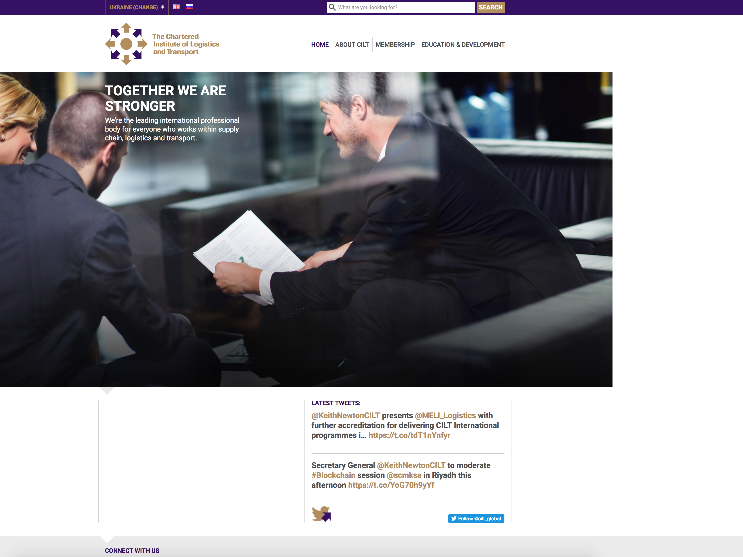

1. CREATING A JOURNEY

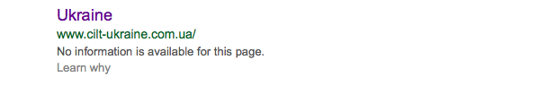

What was checked? | Action required
Search: The meta titles and descriptions have not been optimized for Google | Optimise the page titles and descriptions
Business page: There is no Google business page available for this location | Create a Google business page to help boost SEO and to make your location more accessible
Https present: No | The website should have a trusted SSL Digital Certificate (this will show as a green padlock)

2. BRAND COMPLIANCE

What was checked? | Action required
Logo: The correct logo has been used
Photography: A mix of good quality stock images have been used throughout the website. Many of which reflect the nature of CILT
Tone of voice: The wording is not professional or succinct | Please refer to the tone of voice section in the brand guidelines and look to re-write the copy in a more professional and engaging way. Also look at the main website: http://ciltinternational.org for reference of tone and wording. Consider having the website proofread
Colour: Correct
Font: Correct
Link back to CILT International: Correct

3. USER INTERFACE DESIGN

What was checked? | Action required
Homepage proposition: On brand and uses the “Stronger Together” statement
Design: the design is clean, clear and appealing with good imagery
Typography: Correct
Favicon: The correct favicon has been used
Feedback: Good
Text within images: No
Accessibility: Good
Responsive: This website is responsive to mobile devices. Good design, layout and is user-friendly

4. CONTENT AND INFORMATION ARCHITECTURE

What was checked? | Action required
Country selector iframe: Present
Navigation: User-friendly. The navigation is condensed, the menu highlights so the user always knows where they are and the logo links back to the homepage from every page
Find membership details: The dedicated area for membership is clearly marked in the top navigation bar. The different types of membership are clearly identified and supported with images. Application forms are missing and there appears to be no guidance on joining | Add guidance in completing the application form and clear information on how and where to submit it. Refer to http://ciltinternational.org for content ideas
Broken links: A number of broken links have been found | Recommend using a free link checker, such as https://www.brokenlinkcheck.com/ or similar
WiLAT and YP check: Both present. YP has no content such as (purpose or benefits) other than contact details. WiLAT quotes figures from 2014 | Update content for WiLAT and create new content for YP ASAP to ensure they both have the focus they needs. Please refer to the brand guidelines and the main, international website: http://ciltinternational.org for guidance.
Quality of content: Too wordy on some pages | Suggest using shorter paragraphs. See brand guidelines
Contact details:
The bottom of each page has a link to the contact page
News: There is no dedicated “News” or “Events” area | Consider capacity to add and maintain up to date content. If there is capacity, the site would benefit from up to date News and Events from Ukraine

5. SOCIAL MEDIA
What was checked? | Action required
Social media links: No links are present | Consider capacity. Only add links to social media sites if they are well maintained and already have good level of interaction. Refer to brand guidelines for guidance
LinkedIn account: | Consider capacity and whether an account should be created. Please refer to the brand guidelines for guidance
Facebook account:  Likes:  Last updated: | Consider capacity and whether an account should be created. Please refer to the brand guidelines for guidance
Twitter account:  Followers:  Last updated: | Consider capacity and whether an account should be created. Please refer to the brand guidelines for guidance

