_
COUNTRY: CILT U.A.E
URL: This location is being hosted by the UK website. It does not have it’s own domain name: https://ciltuk.org.uk/About-Us/Nations-Regions-Groups/United-Arab-Emirates

DATE AUDITED: 12 October 2018

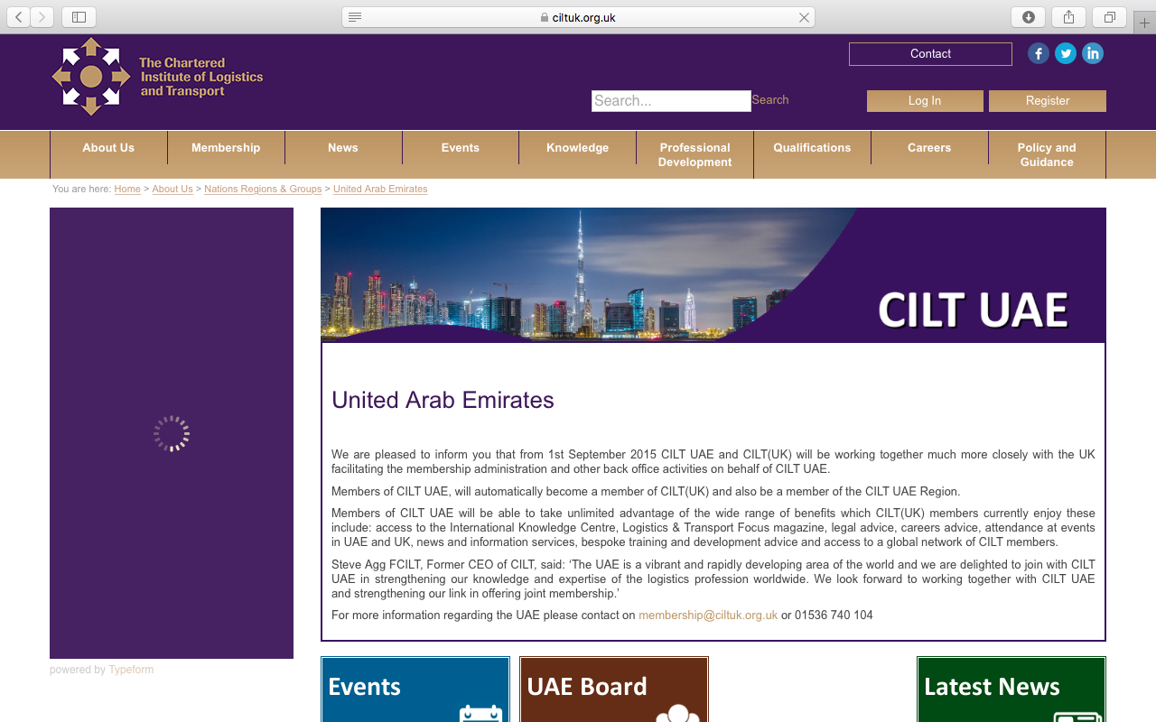

1. CREATING A JOURNEY

What was checked? | Action required
Search: The meta titles and descriptions have not been optimised for Google.  This location is being hosted by the UK website. It does not have it’s own domain | Set up U.A.E Website with own domain.  Obtain domain. Create website. Optimise website titles and descriptions.
Business page: There is no Google business page available for this location . | Create a Google business page to help boost SEO and to make your location more accessible.
Https present: For the UK domain only. | When CILT U.A.E has it’s own domain, the website should have a trusted SSL Digital Certificate (this will show as a green padlock).
2. BRAND COMPLIANCE

What was checked? | Action required
Logo: The correct logo has been used, however it does not meet the logo exclusion zone guidelines. | Please refer to brand guidelines.
Photography: CILT UAE has only one page, found within the UK website. There is one image of buildings which does not portray the nature of CILT. | When the UAE has it’s own domain, the website would benefit from having numerous positive and inclusive on brand images throughout. Please refer to the brand guidelines for guidance.
Tone of voice: n/a | n/a – due to being hosted on the UK website.
Colour: n/a | n/a – due to being hosted on the UK website.
Font: n/a | n/a – due to being hosted on the UK website.
Link back to CILT International: This location is hosted by the UK Website. | n/a – due to being hosted on the UK website.

3. USER INTERFACE DESIGN

What was checked? | Action required
Homepage proposition: | n/a – due to being hosted on the UK website.
Design: | n/a – due to being hosted on the UK website.
Typography: | n/a – due to being hosted on the UK website.
Favicon: | n/a – due to being hosted on the UK website.
Feedback: | n/a – due to being hosted on the UK website.
Text within images: | n/a – due to being hosted on the UK website.
Accessibility: | n/a – due to being hosted on the UK website.
Responsive: | n/a – due to being hosted on the UK website.

4. CONTENT AND INFORMATION ARCHITECTURE

What was checked? | Action required
Country selector Iframe: | n/a – due to being hosted on the UK website.
Navigation: | n/a – due to being hosted on the UK website.
Find membership details: | n/a – due to being hosted on the UK website.
Broken links: | n/a – due to being hosted on the UK website.
WiLAT and YP check: | n/a – due to being hosted on the UK website.
Quality of content: | n/a – due to being hosted on the UK website.
Contact details: | n/a – due to being hosted on the UK website.
News: | n/a – due to being hosted on the UK website.

5. SOCIAL MEDIA
What was checked? | Action required
Social media links: None. The website is hosted by the CILT UK. All social media links go to the UK sites | n/a – due to being hosted on the UK website.
LinkedIn account: | n/a – due to being hosted on the UK website
Facebook account:  Likes:  Last updated: | n/a – due to being hosted on the UK website.
Twitter account:  Followers:  Last updated: | n/a – due to being hosted on the UK website.

