_
COUNTRY: CILT SOUTH AFRICA
URL: https://www.ciltsa.org.za/
DATE AUDITED: 15th September 2018



1. CREATING A JOURNEY

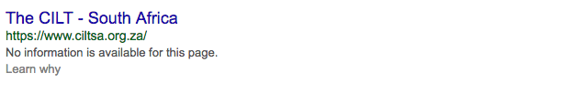

What was checked? | Action required
Search: The meta titles and descriptions are not available. | Add page titles and descriptions asap.
Business page: Present. | Suggest completing opening times, adding logo and other branded content.
Https present: Present but not secure: | https:// Website should have an SSL certificate (this will make a green padlock appear)

2. BRAND COMPLIANCE

What was checked? | Action required
Logo: Correct logo is used on homepage with good space around it. | N/A 
Photography: On brand and looking dynamic, positive, engaging, inclusive and authentic. | N/A
Tone of voice: On brand and feels inclusive, engaging and indicative of what CILT does. | N/A
Colour: The correct brand colours have been used. | N/A
Font: Correct web font has been used. | N/A
Link back to CILT International: Yes, in the country selector iframe | Would benefit from a link back to the main, international website: http://ciltinternational.org/ through the ‘Contact Us’ section too.

3. USER INTERFACE DESIGN

What was checked? | Action required
Homepage proposition: The name of the branch and Stronger Together have been used, alongside current news and easy to absorb information. | N/A
Design: The design is on brand. | N/A
Typography: Great! | N/A
Favicon: A correct favicon has been used. | N/A
Feedback: Work smoothly, clearly and on brand. | N/A
Text within images: On the homepage there is illegible logo over an image. This is poor practice for accessibility and brand reasons. | Please remove text from images and have as html / text.  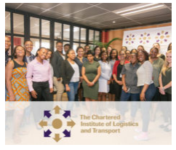
Accessibility: Text is not legible over this image due to poor resolution. | Change resolution.
Responsive: This website is very responsive to mobile devices. A great user experience! | N/A

4. CONTENT AND INFORMATION ARCHITECTURE

What was checked? | Action required
Country selector iframe: Present. | N/A
Navigation: Two levels of main navigation have been used. Content has been grouped very clearly and provides a smooth user-centered experience. | N/A
Find membership details: There was a dedicated area for membership with engaging and positive content. | N/A
Broken links: There are a number of broken links across the website or dead-end links. | Suggest using a free link checker. Like this http://www.brokenlinkcheck.com/ or similar.
WiLAT and YP check: Present with great content and on brand. | N/A
Quality of content: Engaging, modern, informative, inclusive, dynamic and on brand. | N/A
Contact details: Easily accessible. | N/A
News: There isn’t a dedicated ‘News and Events’ section. But there are news articles and links on the homepage. | The site would benefit from a ‘News & Events’ tab in the top bar navigation.

5. SOCIAL MEDIA
What was checked? | Action required
Social media links: Present on the website and on brand | N/A
LinkedIn account: Can locate from website, but it is not named South Africa. Is this account for South Africa? I cannot find a link from a google search for South Africa either… | This is an ambiguous account – which country?  The content on the link from website has repeated imagery and isn’t very engaging.  Consider capacity and whether an account should be created or updated. If this is South Africa please refer to the brand guidelines for guidance. Assess whether training issues need implementing.
Facebook account: Can locate from website.  Like: 975 people like this page.  Last updated: September 2018 | Please refer to the brand guidelines for guidance and change the cover image. Repeated logo use is not ideal.  Consider capacity and whether account should be given staff training, to bring it up to speed.  Content that was posted previously has few likes and varied in quality.
Twitter account: Can locate from website.  Followers: 212 people  Likes: 10  Last updated: September 2018 | Please refer to the brand guidelines for guidance on logo and image uses and change the cover image.  Consider capacity and whether an account should be retired given the period of direct inactivity. The posts are mainly linked in from Facebook. Assess whether this is due to capacity or training issues.

