_
COUNTRY: CILT Singapore
URL: https://cilt.org.sg
DATE AUDITED: 12 October 2018

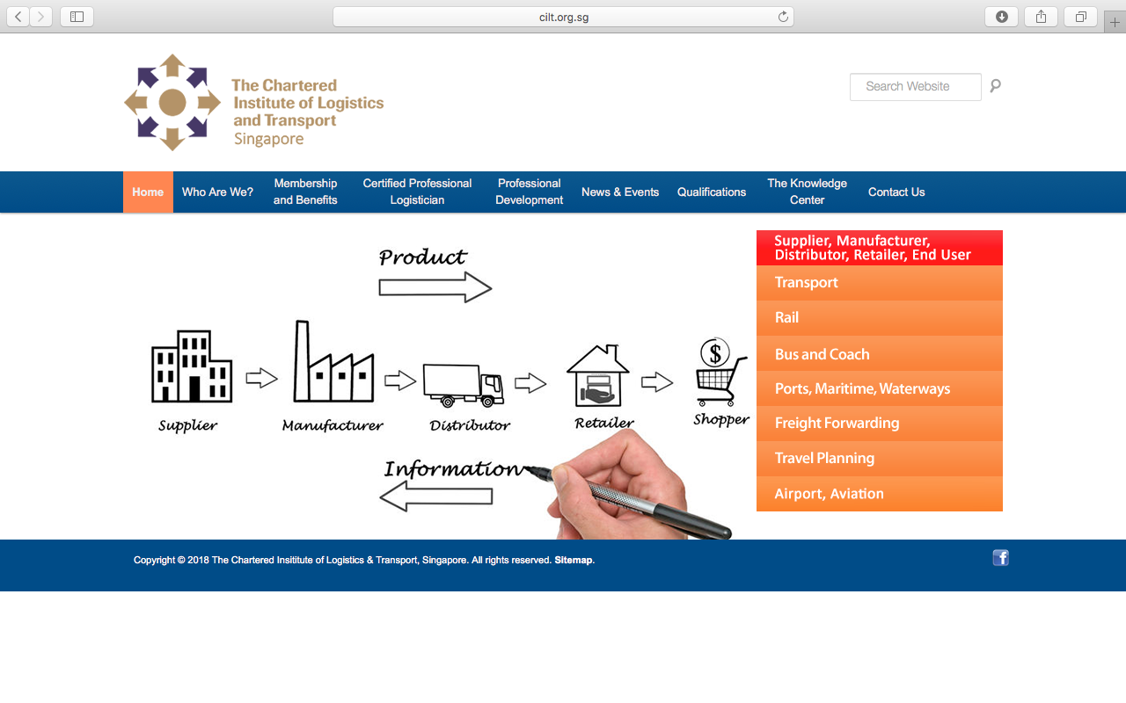

1. CREATING A JOURNEY

What was checked? | Action required
Search: The meta titles and descriptions do not appear to have been optimised for Google. | Optimise titles and descriptions.
Business page: Present. | Suggest completing opening times, adding logo and other branded content.
Https present: No. | The website should have a trusted SSL Digital Certificate (this will show as a green padlock).

2. BRAND COMPLIANCE

What was checked? | Action required
Logo: The correct logo has been used but it should not have the country name below it. | Please remove the country name below the logo.
Photography: the homepage has overbearing stock images of transport. This does not portray the nature of CILT. | The website would benefit from having more inclusive on brand images throughout. Please refer to the brand guidelines.
Tone of voice: The style of language is factual and informative but not engaging or inclusive. | Please refer to the tone of voice section in the brand guidelines and look to re-write the copy in an inclusive and engaging way. Also look at the main website: http://ciltinternational.org for reference of tone.
Colour: The correct brand colours have not been used. | Please use the correct colours as highlighted in the brand guidelines. Refer to http://ciltinternational.org for guidance.
Font: The correct font has been used.
Link back to CILT International: There is no obvious link back to the main website: http://ciltinternational.org. The link on the “Who Are We?” page” does not work. | Please add clear links back to the main international website: http://ciltinternational.org/

3. USER INTERFACE DESIGN

What was checked? | Action required
Homepage proposition: There is no statement or proposition. There is just imagery that is business, transport and logistics-heavy and shows no suggestion of an organisation that networks and supports workers. | Consider the layout of the homepage and introducing ‘Stronger Together’ statement. Change the imagery to inclusive and appealing images, such as workers together and add copy that focuses concisely on what CILT do.  Please refer to the brand guidelines for guidance and look at the main website: http://ciltinternational.org for reference.
Design: Not on brand. Too factual and too wordy. This is not an appealing or dynamic website. | Please refer to brand guidelines.
Typography: Consistent. Typeface font and spacing are good.
Favicon: No favicon has been used. | Please use the graphic icon as per http://ciltinternational.org
Feedback: Good.
Text within images: Yes. | See below.
Accessibility: Text has been used on images. This is poor practice for accessibility reasons for people using screen readers but also for Google and SEO purposes. | Please remove text from images and save as html / text. Particularly the large image on the homepage.
Responsive: This website is not responsive to mobile devices. | Please ensure the website is made responsive for mobile devices.

4. CONTENT AND INFORMATION ARCHITECTURE

What was checked? | Action required
Country selector Iframe: Missing. | Please add to the top of the website. See http://ciltinternational.org and refer to the brand guidelines.
Navigation: Two levels of main navigation have been used. The way content has been grouped does not provide a smooth or clear user-centred experience. | Suggest navigation is condensed and rationalised under fewer labels.
Find membership details: There is a dedicated area for membership that is clearly presented in the top navigation bar. The information on different types of membership is a little confused and the application form guidance is missing. | Reword the information on the membership pages to be appealing and user-friendly. Add guidance notes for the application form, including where and how to submit it. Consider having this area proofread.
Broken links: The broken link checker was unable to run due to a Robot.txt file being in place, this will prevent Google from indexing your website. | Suggest using a free link checker. Like this: http://www.brokenlinkcheck.com or similar.
WiLAT and YP check: The Youth Chapter has a page within the “membership and benefits” section  WiLAT is not mentioned in the website | Create new content for WiLAT asap and ensure it has the focus it needs. Make sure Young Professionals has engaging and inspiring content. Please refer to the brand guidelines and the main international website: http://ciltinternational.org for guidance.
Quality of content: Wordy in places with long paragraphs. | Suggest using shorter paragraphs. See brand guidelines.
Contact details: There is a designated area on the navigation bar leading to the office contact details.
News: There is a page of news showing events and opportunities that are up to date.

5. SOCIAL MEDIA
What was checked? | Action required
Social media links: There are currently no links out to social media accounts on the website. | Consider capacity. Only add links to social media sites if they are well maintained and already have good level of interaction. Refer to brand guidelines for guidance.
LinkedIn account: Found searching within LinkedIn:  https://www.linkedin.com/in/ciltsingapore/ | Consider capacity and whether an account should be maintained. Please refer to the brand guidelines for guidance.
Facebook account: Can be found with a Facebook search:  https://www.facebook.com/CILTSingapore/?tn-str=k*F  CILT Singapore have given themselves 1 star out of 5.  The logo used is not on brand.  Likes: 293  Last updated: 5th October 2018 | The incorrect avatar has been used and the black and white logo shouldn’t be used as a header graphic. Please refer to the brand guidelines.
Twitter account: Not found  Followers:  Last updated: | Consider capacity and whether an account should be created. Please refer to the brand guidelines for guidance.

