_
COUNTRY: CILT POLAND
URL: https://www.cilt.pl
DATE AUDITED: 12 October 2018

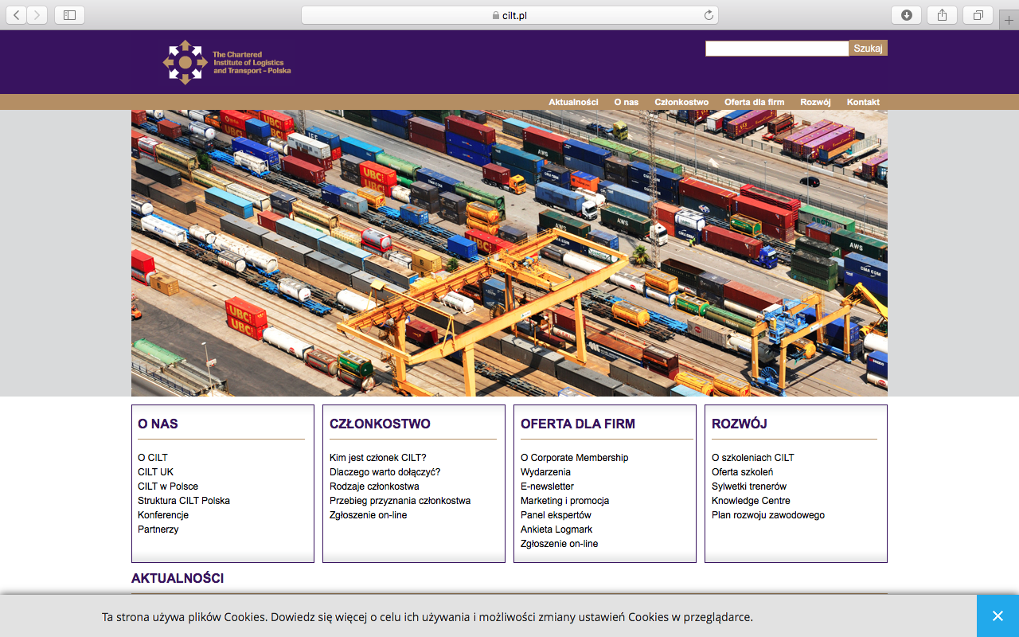

1. CREATING A JOURNEY

What was checked? | Action required
Search: The meta titles and descriptions have not been optimised for Google. | Optimise the page titles and descriptions.
Business page: There is no Google business page available for this location. | Create a Google business page to help boost SEO and to make your location more accessible.
Https present: Yes, but there are insecure links. | Create a Google business page to help boost SEO and to make your location more accessible.

2. BRAND COMPLIANCE

What was checked? | Action required
Logo: The logo size is too small. | Please refer to brand guidelines.
Photography: Stock transport/logistics images have been used that do not portray the nature of CILT | The website would benefit from having more positive and inclusive on brand images throughout, eg images of people interacting. Please refer to the brand guidelines for guidance
Tone of voice: The website has been written in Polish. There is no English version available. | Recommend providing an English version of the website to be audited.
Colour: Brand colours have been used. | The logo links back to the homepage from anywhere on the website. There is too much on the home page. Primary navigation does not stand out.
Font: The correct font appears to have been used.
Link back to CILT International: n/a

3. USER INTERFACE DESIGN

What was checked? | Action required
Homepage proposition: n/a the copy is in Polish. | n/a due to language.
Design:
Typography: | n/a
Favicon: The correct favicon has been used.
Feedback:
Text within images:
Accessibility:
Responsive: This website is not currently responsive to mobile devices. | Please ensure that the website is made responsive to mobile devices.

4. CONTENT AND INFORMATION ARCHITECTURE

What was checked? | Action required
Country selector Iframe: Not apparent. | Please add to the top of the website. See http://ciltinternational.org/ and refer to the brand guidelines.
Navigation: | n/a
Find membership details: n/a | n/a – due to language.
Broken links: A number of broken links were found. | Suggest using a free link checker. Like this http://www.brokenlinkcheck.com or similar.
WiLAT and YP check: n/a | n/a – due to language.
Quality of content: | n/a – due to language.
Contact details: Yes in the footer. | n/a – if this isn’t present within the main navigation, consider adding.
News: n/a | n/a – due to language.

5. SOCIAL MEDIA
What was checked? | Action required
Social media links: n/a website written in Polish. | n/a – due to language.
LinkedIn account: | n/a – due to language.
Facebook account:  Likes:  Last updated: | n/a – due to language.
Twitter account: :  Followers:  Last updated: | n/a – due to language.

