COUNTRY: CILT PHILIPPINES
URL: https://www.ciltp.org
DATE AUDITED:11th October 2018

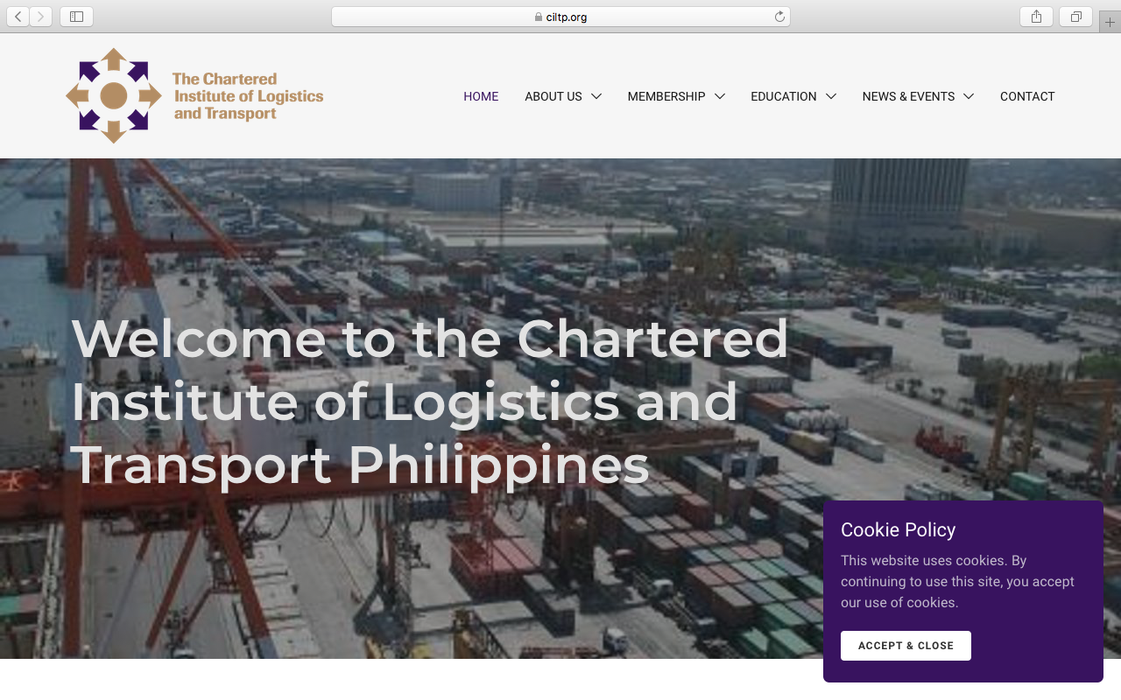

1. CREATING A JOURNEY

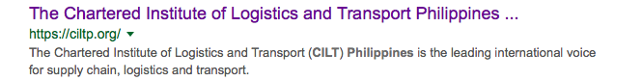

What was checked? | Action required
Search: The meta titles and descriptions have not been optimised for Google. The website does not come up with the search “CILT Philippines” | Optimise the page titles and descriptions.
Business page: There is no Google business page available for this location. | Create a Google business page to help boost SEO and to make your location more accessible.
Https present: Yes, but there are insecure links. | The website should have a trusted SSL Digital Certificate (this will show as a green padlock).

2. BRAND COMPLIANCE

What was checked? | Action required
Logo: The correct logo has been used, however it reduces considerably in size as the user scrolls down the page. | Please refer to the brand guidelines for guidance.
Photography: The photography is too stock, transport, logistics-based. The homepage image is overbearing and does not portray what CILT does. | The website would benefit from having more positive and inclusive images that include people. Please refer to the brand guidelines for guidance.
Tone of voice: The style of language used is not succinct and does not feel inclusive or positive. | Please refer to the tone of voice section in the brand guidelines and look to re-write the copy in an inclusive and engaging way. Also look at the main website: http://ciltinternational.org/ for reference of tone and wording. Consider having the website proofread.
Colour: The website colours are not entirely on brand. | Please use the correct colours as highlighted in the brand guidelines. Also refer to http://ciltinternational.org for guidance.
Font: Incorrect font has been used. | Please refer to brand guidelines.
Link back to CILT International: There is a link at the bottom of the “About us” page. | Please add clear links back to the main, international website: http://ciltinternational.org

3. USER INTERFACE DESIGN

What was checked? | Action required
Homepage proposition: it is not immediately clear what CILT Philippines does. The main image suggests logistics or transport, rather than networking and supporting workers. | Consider the layout of the homepage and introducing the ‘Stronger together’ statement. Focus the copy to summarise what CILT do. Please refer to brand guidelines and look at the main website: http://ciltinternational.org for reference.
Design: The website design is not appealing or user-friendly. | Would benefit from being more ‘on brand’ as per the points above and with some clean dynamic photography.  Please refer to the brand guidelines for guidance and look at the main website: http://ciltinternational.org
Typography: The font is incorrect, too small and the layout needs looking at to allow the typography to communicate visually successfully. | Please refer to the brand guidelines for guidance and look at the main website: http://ciltinternational.org
Favicon: No favicon has been used. | Please use the graphic icon as per http://ciltinternational.org
Feedback: Website feedback is poor in areas. | The website would benefit from better feedback on mouse-overs and clicks so users are aware there is an action to take.
Text within images: No.
Accessibility: Good.
Responsive: This website is responsive to mobile phone devices and is user-friendly.

4. CONTENT AND INFORMATION ARCHITECTURE

What was checked? | Action required
Country selector Iframe: missing. | Please add to the top of the website. See http://ciltinternational.org for reference and refer to the brand guidelines.
Navigation: There is one navigation bar. The logo links back to the homepage from anywhere on the website. The website is user-friendly.
Find membership details: There is a dedicated area for membership in the top navigation. The different membership types in the drop down box have been abbreviated without explanation and the content in the membership area does not feel inclusive or inviting. Clicking on the application form takes you to CILT Malta. There are no instructions on completing the form. | Rewrite the membership section to be more inclusive and user friendly. Add guidance in completing the application form and clear information on how and where to submit it. Refer to http://ciltinternational.org/ for content ideas.
Broken links: There are a number of broken links across the website. | Recommend using a free link checker, such as http://www.brokenlinkcheck.com or similar.
WiLAT and YP check: Both are present
Quality of content: Overall informative. | Consider making the paragraphs smaller and having the site proof-read
Contact details: These can be found under “Contact” in the top navigation bar | Recommend adding job titles for the contacts and an email address
News: Found in the top navigation bar. Split into International and Local. The international takes the user to the international website pages below the Philippines page, which looks messy and is confusing. The local news and events shows “We are currently setting up our operations and will be onine fully within the next month” | Consider capacity to add and maintain up to date content. If there is capacity, the site would benefit from up to date “News and Events” from Philippines. If there is no capacity, please hide or remove these tabs. Consider having the pages proofread

5. SOCIAL MEDIA
What was checked? | Action required
Social media links: There are no links out to social media accounts on the current website | Consider capacity. Only add links to social media sites if they are well maintained and already have good level of interaction. Refer to brand guidelines for guidance
LinkedIn account: Unable to locate from a search on the LinkedIn website | Consider capacity and whether an account should be created. Please refer to the brand guidelines for guidance.
Facebook account: Unable to locate from a search on Facebook | Consider capacity and whether an account should be created. Please refer to the brand guidelines for guidance
Twitter account: Unable to locate from website  Link found: No | Consider capacity and whether an account should be created. Please refer to the brand guidelines for guidance

