_
COUNTRY: CILT MALTA
URL: http://www.ciltmalta.com
DATE AUDITED: 12 October 2018

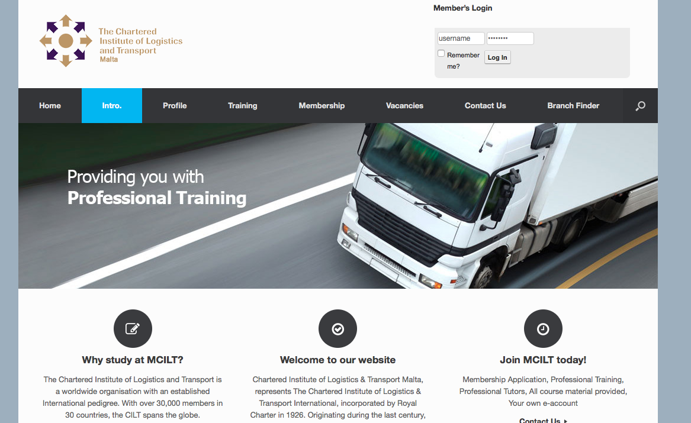

1. CREATING A JOURNEY

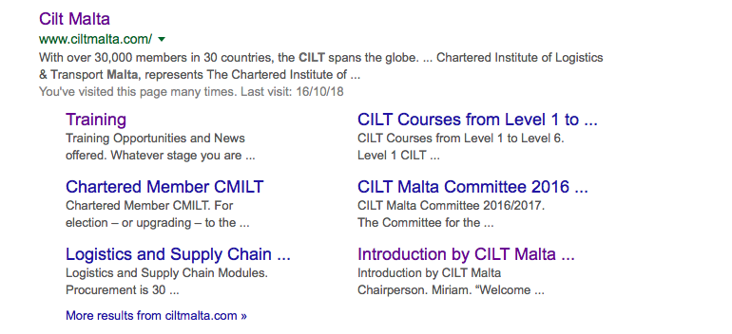

What was checked? | Action required
Search: The meta titles and descriptions appear to have been optimised for Google.
Business page: There is no Google business page available for this location. | Create a Google business page to help boost SEO and to make your location more accessible.
Https present: No. | The website should have a trusted SSL Digital Certificate (this will show as a green padlock).

2. BRAND COMPLIANCE

What was checked? | Action required
Logo: The correct logo has been used.
Photography: Stock transport and logistics images have been used which do not portray the nature of CILT. | The website would benefit from having more positive and inclusive on brand images throughout. Please refer to the brand guidelines.
Tone of voice: The style of language used is wordy and factual. | Please refer to the tone of voice section in the brand guidelines and look to re-write the copy in an inclusive and engaging way. Also look at the main website: http://ciltinternational.org for reference of tone.  Consider having the website proofread.
Colour: the correct brand colours have not been used throughout the website. | Please use the correct colours as highlighted in the brand guidelines. Also refer to http://ciltinternational.org for guidance.
Font: The correct font has been used.
Link back to CILT International: There is no obvious link back to the main website: http://ciltinternational.org, however the “branch finder” option takes the user to CILT international. | Please add clear links back to the main, international website: http://ciltinternational.org

3. USER INTERFACE DESIGN

What was checked? | Action required
Homepage proposition: Not on brand. The key proposition for the website is training. This does not feel appealing or appear inclusive and does not portray the warmth CILT wish to portray. | Focus the copy and imagery to be welcoming to all and to summarise more concisely what CILT do.
Design: The design is clear and simple, user-friendly, however the colours and images are not on-brand. | Please refer to brand guidelines.
Typography: Clear headings, limited line length, good spacing between lines and sufficient colour contrast.
Favicon: Missing. | Please add to the top of the website. See http://ciltinternational.org and refer to the brand guidelines.
Feedback: There is feedback on the images and the main nav but very little on the buttons. | Consider adding in more feedback so it is clear to users that they can click content.
Text within images: None present.
Accessibility: Good.
Responsive: The website is responsive but the membership area pushes the content too far down the page, and the navigation could be improved. | Explore a better way for the membership login to appear for mobile devices and look at ways to improve the navigation. See ciltinternational.org

4. CONTENT AND INFORMATION ARCHITECTURE

What was checked? | Action required
Country selector iframe: Not on brand. There is a “branch finder” on the navigation bar. | Please add to the top of the website. See http://ciltinternational.org for reference and refer to the brand guidelines.
Navigation: User-friendly. The navigation is condensed. Primary navigation stands out. The logo links back to the homepage from anywhere on the website.
Find membership details: There is a dedicated area for membership clearly marked in the main navigation bar. There are no guidelines with the membership form (such as where and how to submit the completed form). The benefits of membership are not apparent. | Rewrite the membership section to be more inclusive and user friendly. Add guidance in completing the application form and clear information on how and where to submit it. Refer to http://ciltinternational.org for content ideas.
Broken links: None found
WiLAT and YP check: Not mentioned. | Create new content for WiLAT and YP asap to ensure they have the focus they need. Please refer to the brand guidelines and the main, international website: http://ciltinternational.org for reference.
Quality of content: Good. User-friendly. On the whole, paragraphs have been kept short, there is no jargon.
Contact details: There is a page clearly marked on the main navigation bar. There are 2 email addresses. A postal address, office navigation and telephone numbers are missing. | Include a postal address, directions to the office and telephone numbers to the “Contact Us” page.
News: There is no dedicated news area. Articles at the bottom of the homepage are out of date. | Remove out of date articles from the homepage. Consider capacity to add and maintain up to date content. If there is capacity, the site would benefit from up to date News and Events from CILT Malta.

5. SOCIAL MEDIA
What was checked? | Action required
Social media links: There are currently no links out to social media accounts on the website. | Consider capacity. Only add links to social media sites if they are well maintained and already have good level of interaction. Refer to brand guidelines for guidance
LinkedIn account: No | Consider capacity and whether an account should be created. Please refer to the brand guidelines for guidance
Facebook account: No  Likes:  Last updated: | Consider capacity and whether an account should be created. Please refer to the brand guidelines for guidance
Twitter account: No  Followers:  Last updated: | Consider capacity and whether an account should be created. Please refer to the brand guidelines for guidance

