_
COUNTRY: CILT MALAYSIA
URL: http://www.cilt-m.com.my
DATE AUDITED: 12 October 2018

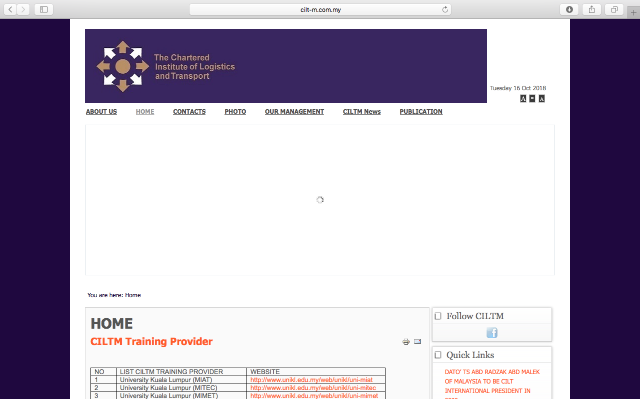

1. CREATING A JOURNEY

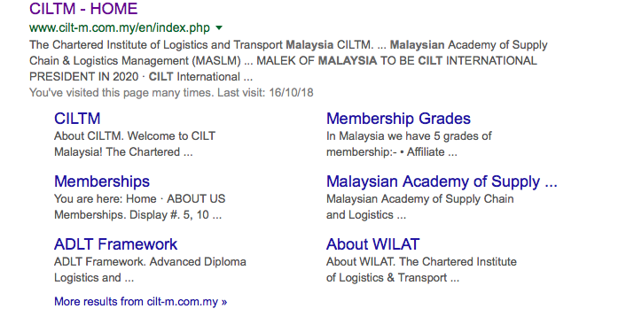

What was checked? | Action required
Search: The meta titles and descriptions do not appear to have been optimised for Google. | Optimise the page titles and descriptions.
Business page: There is no Google business page available for this location. | Create a Google business page to help boost SEO and to make your location more accessible .
Https present: No. | The website should have a trusted SSL Digital Certificate (this will show as a green padlock).

2. BRAND COMPLIANCE

What was checked? | Action required
Logo: The correct logo has been used.
Photography: There is a distinct lack of photographs throughout the website. | The website would benefit from having more positive and inclusive on brand images throughout. The images can include people interacting in various level roles to reflect the nature of CILT. Please refer to the brand guidelines.
Tone of voice: The wording does not portray the warmth or inclusion indicative of CILT. | Please refer to the tone of voice section in the brand guidelines and look to re-write the copy in an inclusive and engaging way. Also look at the main website: http://ciltinternational.org for reference of tone and wording. Consider having the website proofread.
Colour: The correct brand colours have been used throughout the website.
Font: The correct font has been used.
Link back to CILT International: Yes, the link on the home page takes the user to CILT international .

3. USER INTERFACE DESIGN

What was checked? | Action required
Homepage proposition: The homepage is blank as at 12 October.  Having re-checked on 24 October, there’s just one rather ugly image advertising a logistics symposium on 9 November. Adding this graphic now means that the date is partly obscured on the top right of the page. | Redesign the layout of the home page. Consider introducing the ‘Stronger Together’ statement. Change the copy and imagery to be more welcoming and inclusive and to focus more concisely on what CILT do. Please refer to the brand guidelines for guidance and look at the main website: http://ciltinternational.org for reference.  Use the home page as described above, events should appear in a News or Events section.
Design: The design is wordy and visually unappealing. It is not on brand. | The homepage would benefit from prioritising key content, using on brand imagery and being user-friendly.
Typography: Uninspiring and not on brand. | Simplify the use of fonts and refer to the guidelines and ciltinternational.org for best practice.
Favicon: No favicon is present. | Please use the graphic icon as per http://ciltinternational.org
Feedback: Some but not done well. | Simplify the use of fonts and refer to the guidelines and ciltinternational.org for best practice.
Text within images: No images present. | Add in some on-brand imagery to make the site feel more engaging.
Accessibility: OK.
Responsive: The website is not responsive to mobile devices. | Ensure the website is made responsive for all mobile devices.

4. CONTENT AND INFORMATION ARCHITECTURE

What was checked? | Action required
Country selector iframe: Missing. | Please add to the top of the website. See http://ciltinternational.org and refer to the brand guidelines.
Navigation: Navigation has errors, pages missing. The way content has been grouped is confusing and does not provide a clear user-experience. | Suggest re-design the website and navigation bar. Remove links to missing pages and hide pages with missing content. See brand guidelines.
Find membership details: Missing. | Create new content for this area asap. Consider making it a prominent, easy to access, navigation tab in itself. Please refer to the brand guidelines and use the main, international website: http://ciltinternational.org for reference.
Broken links: There are numerous broken links throughout the website. | Suggest using a free link checker. Like this http://www.brokenlinkcheck.com or similar .
WiLAT and YP check: There is a link to WiLAT website http://www.wilat.org and a link to the CILT Malaysia WiLAT Facebook page from the home page.  There is no dedicated areas for WiLAT Malaysia. There is no apparent mention of YP on the website. | Add or create new content for WiLAT and YP asap giving them a dedicated area linked to the main navigation bar and ensure they have the focus they need.  Please refer to the brand guidelines and the main, international website: http://ciltinternational.org for guidance.
Quality of content: Some pages are missing. Some content is missing. Available content is messy and unappealing. | Avoid pages of lists. Rewrite the website to be user-friendly and inspiring. Please refer to the main, international website: http://ciltinternational.org for guidance.
Contact details: There is a designated area for contact details.
News: The dedicated link to the news page on the homepage navigation bar is broken. At the bottom of the home page there is a small section of “Latest News” which has 5 links to undated content. | If there is a capacity to create and maintain up to date content, the site would benefit from a dedicated area for up to date “News and Events. If there is no capacity, please hide or remove these tabs and areas.

5. SOCIAL MEDIA
What was checked? | Action required
Social media links: There are links to CILT Malaysia Facebook and WiLAT CILT Malaysia Facebook pages | Consider capacity. Only add links to social media sites if they are well maintained and already have good level of interaction. Refer to brand guidelines for guidance.
LinkedIn account: Not found | Consider capacity and whether an account should be created. Please refer to the brand guidelines for guidance.
Facebook account: There are 2 CILT Malaysia Facebook accounts:  https://www.facebook.com/pg/ciltmalaysia/about/?ref=page_internal and  https://www.facebook.com/ciltmsia.ymc  The professional looking page is not the page linked to the website. This is messy. The professional looking page was last updated 2 years ago.  There is also a 3rd CILT Malaysia Facebook page for CILT Malaysia WiLAT: https://www.facebook.com/msia.wilmas | Consider capacity to maintain one of these CILT Malaysia Facebook accounts and consider whether they should be consolidated or closed down. If electing to consolidate CILT Malaysia Facebook accounts then have just one with a clear link from the CILT Malaysia website home page.  With the CILT WiLAT Facebook page, consider capacity to maintain this site. The imagery is not on brand. See brand guidelines.
Twitter account: Yes  Followers: 266  Last updated: 10th October 2018 | Consider capacity to maintain the Twitter account and, if so, add an appropriate Twitter icon/link – refer to the brand guidelines for guidance.

