_
COUNTRY: CILT MACAO
URL: https://www.cilt.mo
DATE AUDITED: 9th October 2018

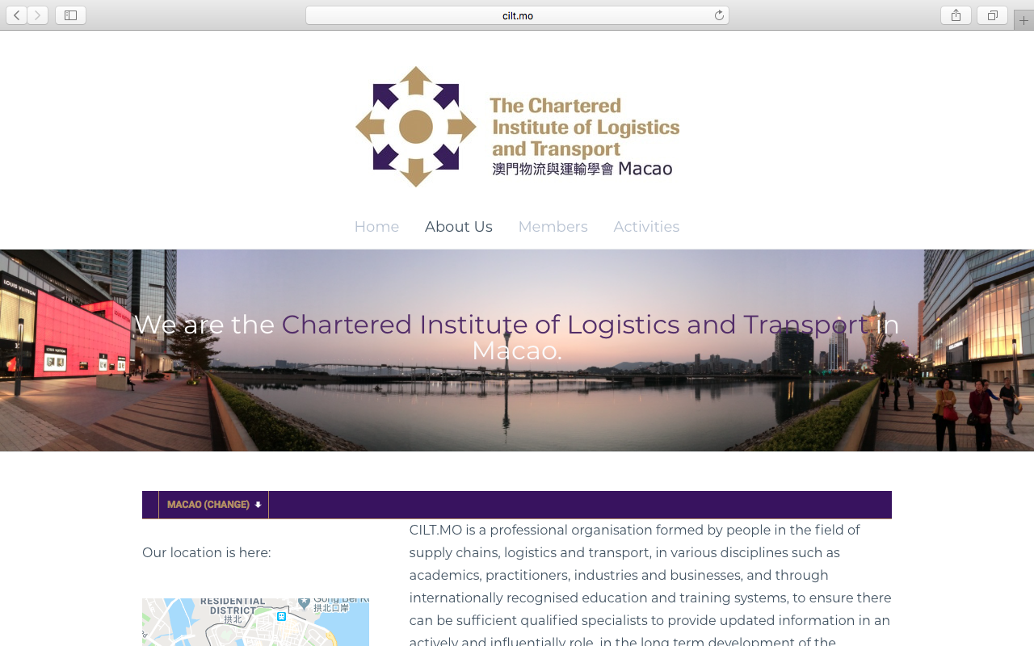

1. CREATING A JOURNEY

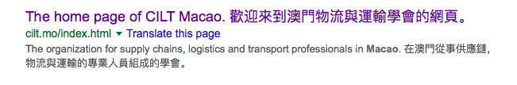

What was checked? | Action required
Search: The meta titles and descriptions do not appear to have been optimised for Google. | Optimise the page titles and descriptions.
Business page: There is no Google business page available for this location. | Create a Google business page to help boost SEO and to make your location more accessible.
Https present: No. | Website should have a trusted SSL Digital Certificate (this will show as a green padlock).

2. BRAND COMPLIANCE

What was checked? | Action required
Logo: The correct logo has been used but has the name underneath – this is not on brand. | Please refer to brand guidelines for guidance.
Photography: A mix of photography is used throughout the site, ranging from stock transport images to authentic but not inspiring or on brand.  The image on the homepage is overbearing and does not portray CILT. | The website would benefit from having more, smaller, on brand images that include people and look welcoming. Please refer to the brand guidelines for guidance.
Tone of voice: Long sentences have been used. The style of language is factual but does not feel inclusive, positive or indicative of what CILT does. | The website would benefit from having more warmth and a more inclusive tone. Please refer to the tone of voice section in the brand guidelines and look to re-write the copy in an inclusive and engaging way. Also look at the main website: http://ciltinternational.org/for reference of tone. Consider having the website proofread.
Colour: The correct brand colours have been used.
Font: An incorrect font has been used throughout the site. | Check the whole site and refer to brand guidelines for guidance.
Link back to CILT International: There is no obvious link back to the main website: http://ciltinternational.org, however the branch selector bar takes the user to CILT international . | Please add clear links back to the main, international website: http://ciltinternational.org

3. USER INTERFACE DESIGN

What was checked? | Action required
Homepage proposition: It is not clear from the homepage what CILT Macao does. | Consider the layout of the homepage and introducing the ‘Stronger Together’ statement. Focus the copy to summarise more concisely what CILT do. Please refer to the brand guidelines for guidance and look at the main website: http://ciltinternational.org for reference.
Design: The design is basic. There are few images and little content. The site states it is under construction. | Please refer to brand guidelines and the main website http://ciltinternational.org for guidance.
Typography: Not on brand. | See http://ciltinternational.org and refer to the brand guidelines.
Favicon: No favicon has been used. | Please use the graphic icon. Use http://ciltinternational.org for reference.
Feedback: Good.
Text within images: Yes. On the “About Us” page there is type over an image. | See below.
Accessibility: This is poor practice for accessibility reasons for people using screen readers and for Google and SEO purposes. | The text is not accessible over the imagery that has been used please refer to the brand guidelines.
Responsive: This website is responsive to mobile devices.

4. CONTENT AND INFORMATION ARCHITECTURE

What was checked? | Action required
Country selector iframe: Present.
Navigation: Basic, so easy to use. The logo links back to the homepage from anywhere on the website.
Find membership details: There is a dedicated area for membership in the top navigation, however the content is limited and it is not engaging or inviting. The instructions are not clear (eg where to send the completed application form to). The “join now” button at the bottom of “About Us” leads to an application form but again there are no further instructions. | See http://ciltinternational.org for reference and refer to the brand guidelines.
Broken links: There are broken links in the membership and contact areas. | Recommend using a free link checker, such as https://www.brokenlinkcheck.com/ or similar.
WiLAT and YP check: Not present. | Please create new content for these areas asap. Refer to http://ciltinternational.org/ for content ideas if required.
Quality of content: This is basic. There are 4 pages. The homepage gives no information. The About us page is too wordy and lacks images. The membership area is inadequate and the content in Activities is out of date. | Suggest make the content more dynamic and inspiring. Suggest the pages with out of date content are either hidden or updated asap.  See http://ciltinternational.org for guidance and refer to the brand guidelines.
Contact details: An email address can be found at the bottom of the About Us” page but no other information. | Suggest adding names, telephone numbers, email addresses for designated people and an office/site address with directions.
News: A list of historic events can be found under “Activities” but there are no current stories. | If there is a capacity to create and maintain up to date content, the site would benefit from up to date “News and Events”. If there is no capacity, please hide or remove the “Activities” tab.

5. SOCIAL MEDIA
What was checked? | Action required
Social media links: There is a link to 1 social media account on the current website. However, there is confusingly two CILT Macao Facebook accounts | Consider capacity. Only add links to social media sites if they are well maintained and already have good level of interaction. Refer to brand guidelines for guidance.
LinkedIn account: Unable to locate from a search on the LinkedIn website. | Consider capacity and whether an account should be created. Please refer to the brand guidelines for guidance.
Facebook account: Unable to locate from website.  Link found: https://www.facebook.com/CILT.macao/  Further link found: https://www.facebook.com/cilt.mo  Likes: No likes. No reviews.  Last updated: March 2018 | Consolidate the Facebook pages and retire one. Consider capacity and whether these accounts should be consolidated or retired given the periods of inactivity. Consider whether training needs implementing. Please refer to the brand guidelines for guidance.
Twitter account: Unable to locate from website  Link found: No  Followers: n/a  Last updated: n/a | Consider capacity and whether an account should be created. Please refer to the brand guidelines for guidance.

