_
COUNTRY: CILT KAZAKHSTAN
URL: http://cilt.kz
DATE AUDITED: 12 October 2018

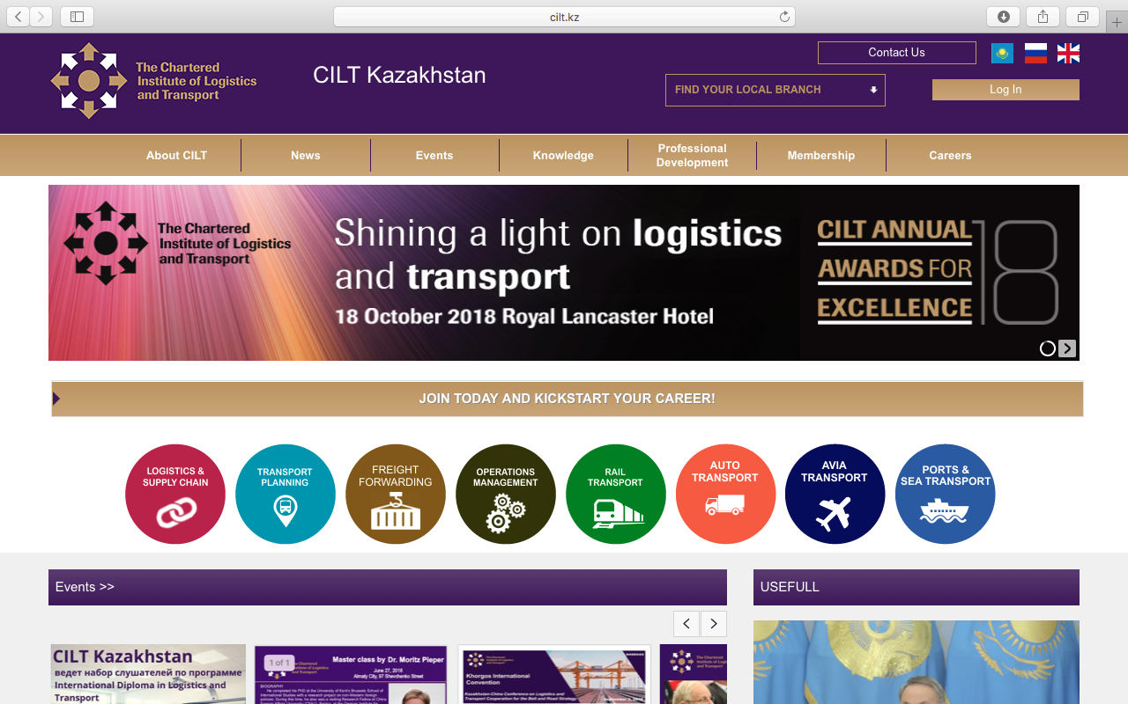

1. CREATING A JOURNEY

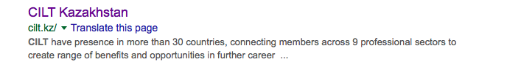

What was checked? | Action required
Search: The meta titles and descriptions do not appear to have been optimised for Google. | Optimise website titles and descriptions.
Business page: There is no Google business page available for this location. | Create a Google business page to help boost SEO and to make your location more accessible.
Https present: No. | The website should have a trusted SSL Digital Certificate (this will show as a green padlock).
2. BRAND COMPLIANCE

What was checked? | Action required
Logo: The logo has been used incorrectly in places. The colours and exclusion zones on the homepage slides do not meet brand guidelines. | Please refer to brand guidelines.
Photography: A mix of good quality stock images that look welcoming. Various images of CILT board members and key member profiles. | The website would benefit from more on brand images throughout the website. Please refer to brand guidelines.
Tone of voice: Much of the wording has been copied from the CILT international website, which is succinct and easy to understand. Some of the content is in Russian. | Keep wording simple and inclusive. Consider having the wording that was not taken from CILT international website proofread.
Colour: The correct brand colours have been used alongside incorrect ones. | Please use the correct colours as highlighted in the brand guidelines.
Font: The correct font has been used
Link back to CILT International: There is no obvious link back to the main website: http://ciltinternational.org. The link on the “who are we page” does not work. The country selector bar automatically takes the user to CILT International. | Please add clear links back to the main, international website: http://ciltinternational.org

3. USER INTERFACE DESIGN

What was checked? | Action required
Homepage proposition: it is not immediately clear what CILT Kazakhstan does. There is no single homepage proposition. There is a band of constantly changing images but no immediately obvious statement that the organisation is there to network and support workers. | The homepage would benefit from prioritising key content. Rather than the carousel. Consider the layout of the homepage and introducing ‘Stronger Together’ statement. Change the copy and imagery to focus more concisely on what CILT do. Please refer to the brand guidelines for guidance and look at the main website: http://ciltinternational.org for reference.
Design: Quite busy and content-heavy. | Please use more on brand images. Please refer to the brand guidelines for guidance and look at the main website: http://ciltinternational.org
Typography: The font is too small. | Increase font size. Would benefit from subheadings. Please refer to brand guidelines.
Favicon: A favicon is present.
Feedback: Good.
Text within images: Yes. | See below.
Accessibility: This is poor practice for accessibility reasons for people using screen readers but also for Google and SEO purposes. | Please remove text within images and have as html / text instead.
Responsive: The design and navigation provide a poor user experience. | Please look at improving the mobile navigation.

4. CONTENT AND INFORMATION ARCHITECTURE

What was checked? | Action required
Country selector iframe: Present.
Navigation: The logo links back to the homepage from anywhere on the website. There is too much on the home page. Primary navigation does not stand out. | Suggest navigation is condensed and rationalised under fewer labels.
Find membership details: The dedicated area for membership is clearly marked in the top navigation bar. There is information on the benefits of membership and the different types. There are no application forms and no guidance on joining. | Rewrite the membership section to be more inclusive and user friendly. Add application forms and guidance in completing them with clear information on how and where to submit them. Refer to http://ciltinternational.org for content ideas.  Consider having this area proofread.
Broken links: There are numerous broken links. | Recommend using a free link checker, such as https://www.brokenlinkcheck.com/or similar.
WiLAT and YP check: Not mentioned. | Create new content for WiLAT and YP asap to ensure they have the focus they need. Please refer to the brand guidelines and the main, international website: http://ciltinternational.org for reference.
Quality of content: This varies. Busy in areas and empty in others. | Suggest pages without content are hidden until new content is created. See brand guidelines.
Contact details: There is a clear and easy link from the top of each page.
News: There is a designated area, accessible from the main navigation bar but there is no content. | If there is a capacity to add and maintain up to date content, the site would benefit from up to date “News and Events”. If there is no capacity, please hide or remove these sections.

5. SOCIAL MEDIA
What was checked? | Action required
Social media links: There are no links to CILT Kazakhstan social media accounts. The website has links to the CILT UK social media accounts. | Only add links to CILT Kazakhstan social media sites if they are well maintained and already have good level of interaction. Refer to brand guidelines for guidance.
LinkedIn account: No. | Consider capacity and whether an account should be created. Please refer to the brand guidelines for guidance
Facebook account: CILT Kazakhstan page can be found with a Facebook search: https://www.facebook.com/cilt.kazakhstan  Likes:  Last updated: | This site should be retired as it is not being used and has been set up as a personal profile, not a business page.  Consider capacity to build a company Facebook page and maintain engagement (regular relevant posts etc).
Twitter account: No  Followers:  Last updated: | Consider capacity and whether an account should be created. Please refer to the brand guidelines for guidance

