_
COUNTRY: CILT IRELAND
URL: https://www.cilt.ie
DATE AUDITED: 12 October 2018

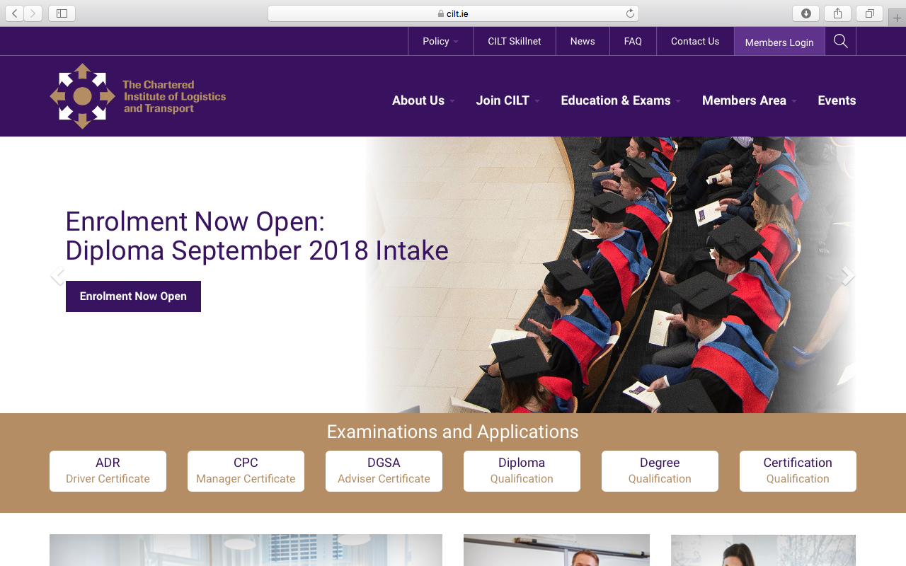

1. CREATING A JOURNEY

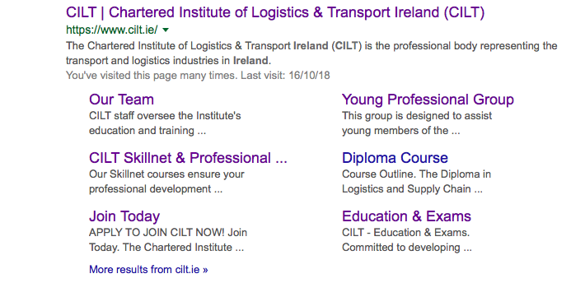

What was checked? | Action required
Search: The meta titles and descriptions appear to have been optimised for Google.
Business page: There is no Google business page available for this location. | Create a Google business page to help boost SEO and to make your location more accessible.
Https present: Yes, but there are insecure links. | The website should have a trusted SSL Digital Certificate (this will show as a green padlock).

2. BRAND COMPLIANCE

What was checked? | Action required
Logo: The correct logo has been used, however it does not meet the logo exclusion zone guidelines. | Please refer to brand guidelines.
Photography: A good mix of stock and authentic on brand images.
Tone of voice: the tone feels inclusive, engaging and indicative of what CILT does. | Consider having the website proofread.
Colour: The correct brand colours have been used throughout the website
Font: Incorrect font has been used. | Please refer to brand guidelines.
Link back to CILT International: There is no obvious link back to the main website: http://ciltinternational.org | Please add clear links back to the main, international website: http://ciltinternational.org

3. USER INTERFACE DESIGN

What was checked? | Action required
Homepage proposition: There is no single homepage proposition. There is a band of constantly changing images: the membership image and statement “If we are all together everything is possible” is on brand and portrays CILT well. The rotation of images is a little frustrating. There is no mention of Ireland. | Consider the layout of the homepage and introducing the ‘Stronger Together’ statement.  Change layout to focus more concisely on what CILT do so it is clear when a users lands on the homepage.
Design: On the whole, the design is on brand, clean, appealing and user-friendly
Typography: Spacing, font and typeface are all good. Consistent but not on brand. | Please see brand guidelines
Favicon: A correct favicon has been used.

Feedback: Good.
Text within images: No.
Accessibility: Good.
Responsive: This website is responsive to mobile devices, however it is not immediately obvious what CILT Ireland do. | Suggest adding copy that summarises what CILT Ireland do (as above for the homepage proposition).

4. CONTENT AND INFORMATION ARCHITECTURE

What was checked? | Action required
Country selector iframe: Missing. | Please add to the top of the website. See http://ciltinternational.org for reference and refer to the brand guidelines.
Navigation: The logo links back to the homepage from anywhere on the website. There is too much on the home page. Primary navigation does not stand out. | Suggest navigation is condensed and rationalised under fewer labels. Please refer to brand guidelines.
Find membership details: There is a dedicated area for membership which is clearly marked in the main navigation bar. The area is appealing and user-friendly and the different types of membership are clearly identified. The application forms are easy to find and benefits of membership are well explained.
Broken links: There are a number of broken links across the website. | Suggest using a free link checker. Like this: http://www.brokenlinkcheck.com or similar.
WiLAT and YP check: There are designated areas for both with appealing and inclusive content and imagery. Both are clearly immediately accessible on the homepage and via the “Join CILT” option in the main navigation bar.
Quality of content: Good. Appealing and user-friendly. Paragraphs are kept short.
Contact details: Easily accessible link from the main navigation bar. Relevant and useful information and on brand visually appealing content.
News: A designated area, easy to access. Content is up to date.

5. SOCIAL MEDIA
What was checked? | Action required
Social media links: There are currently links out to social media accounts on the website, at the bottom of each page
LinkedIn account: Website has a link to CILT Ireland
https://www.linkedin.com/company/the-chartered-institute-of-logistics-transport-ireland/ Last updated 2 weeks ago.
A search within LinkedIn also presents CILT Ireland YP::
https://www.linkedin.com/in/young-professionals-cilt-ireland-1a8b4911a/. This was last updated 1 month ago
Facebook account: Also presents with a Facebook search  https://www.facebook.com/CILTIRL/  Logo on brand. It’s not immediately obvious what CILT does  Like: 314  Last updated: less than 24 hours prior to this audit | Add explanation of what CILT does.
Twitter account: On brand. Interesting and engaging content
Followers: 674
Last updated: Less than 24 hours prior to this audit

