_
COUNTRY: CILT INDIA
URL: https://www.ciltindia.in
DATE AUDITED: 9th October 2018

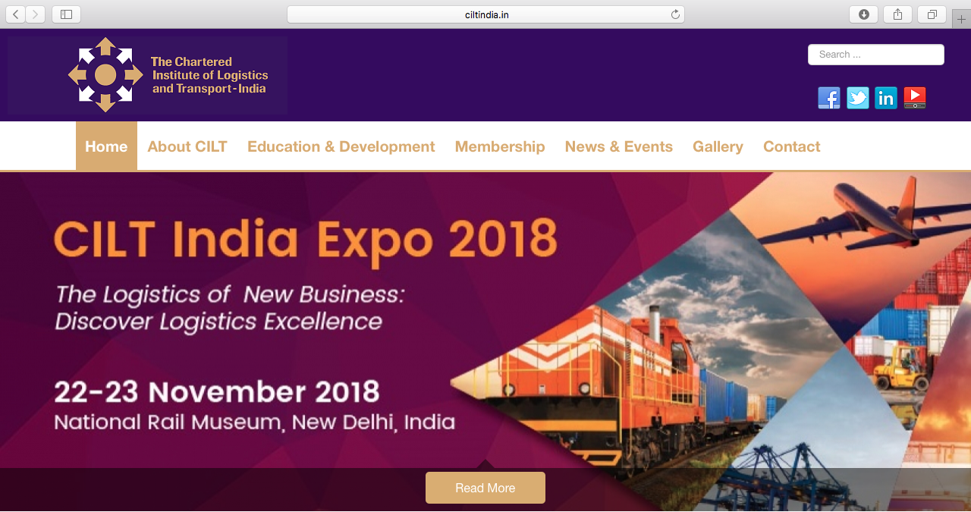

1. CREATING A JOURNEY
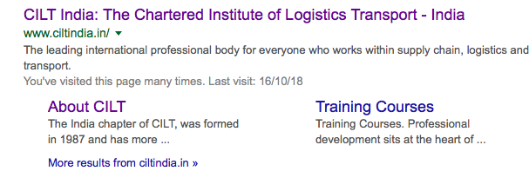
What was checked? | Action required
Search: The homepage meta titles and descriptions are the only pages that appear to have been optimised for Google. | Optimise other page titles and descriptions.
Business page: Present. | Suggest adding logo and other branded content.
Https present: No. | The website should have a trusted SSL Digital Certificate (this will show as a green padlock).
2. BRAND COMPLIANCE

What was checked? | Action required
Logo: The correct logo has been used, however it does not meet the logo exclusion zone guidelines throughout the site. | Please refer to brand guidelines.
Photography: A good range of authentic looking photographs in the membership pages. The home page does not appear to portray the inclusivity and welcome of CILT. | The homepage and Education and News pages could use more on-brand images that include people. Please refer to the brand guidelines for guidance.
Tone of voice: The style of language used doesn’t feel inclusive, positive or indicative of what CILT does. | The website would benefit from being more personable and having a more inclusive tone. Please refer to the tone of voice section in the brand guidelines and look to re-write the copy in an inclusive and engaging way. Also look at the main website: http://ciltinternational.org for reference of tone.  Consider having the website proofread.
Colour: The colours are correct on the website but there are some images with content that use non-brand colours like deep red and orange. | Please refer to the brand guidelines for the correct colours.
Font: The correct font has been used.
Link back to CILT International: There is no obvious link back to the main website: http://ciltinternational.org | Please add clear links back to the main, international website: http://ciltinternational.org/

3. USER INTERFACE DESIGN

What was checked? | Action required
Homepage proposition: There is no one homepage proposition. There is a band of constantly changing images but no immediately obvious statement that the organisation is there to network and support workers. | Consider the layout of the homepage and introducing the ‘Stronger Together’ statement. Focus the copy to summarise more concisely what CILT do. Please refer to the brand guidelines for guidance and look at the main website: http://ciltinternational.org for reference.
Design: Good in areas.
Typography: Line length and spacing are OK.
Favicon: No favicon has been used. | Please use the graphic icon as per http://ciltinternational.org
Feedback: Very good.
Text within images: Yes, see below. | As below.
Accessibility: This is poor practice for accessibility reasons for people using screen readers but also for Google and SEO purposes. | Please remove text within images and have as html / text instead.
Responsive: This website is responsive to mobile devices. It is not immediately obvious what CILT India do on the mobile phone homepage. | The navigation and font size provides a poor user experience and could be made more mobile-friendly.  Add copy that summarises what CILT India do.

4. CONTENT AND INFORMATION ARCHITECTURE

What was checked? | Action required
Country selector iIrame: Missing. | Please add to the top of the website. See http://ciltinternational.org for reference and refer to the brand guidelines.
Navigation: One navigation bar. The site appears user-friendly. The logo links back to the homepage from anywhere on the website.
Find membership details: The dedicated area for membership is clearly marked in the top navigation bar. The different types of membership are clearly identified and backed up with images. The application forms are easy to find but there is no guidance (eg where to return them to). The forms are poor quality and have an India office address at the top and London headquarters address on the bottom of the page. | Re-word the information on the membership pages to be user-friendly. Consider having it proofread.
Broken links: There are a number of broken links across the website. | Recommend using a free link checker, such as https://www.brokenlinkcheck.com/or similar.
WiLAT and YP check: Both are present and easy to access, however the wording is not engaging or inviting . | Recommend rewriting to make these memberships more appealing.
Quality of content: Wordy in places. | Sentences and paragraphs could be reduced. Avoid repetition.
Contact details: The site address, telephone numbers and email address are found in the dedicated area which is clearly marked in the top navigation bar. | Recommend adding nominated individuals .
News: there is a dedicated “News and events” area clearly marked in the top navigation bar. Recent events are all listed and accessible, but the e-magazine, newsletters and results are all at least 1 year out of date. | If there is a capacity to add and maintain up to date content, the site would benefit from up to date “News and Events”. If there is no capacity, please hide or remove these sections.

5. SOCIAL MEDIA
What was checked? | Action required
Social media links: There are links out to social media accounts on the current website
LinkedIn account: The link on the homepage takes the user to the UK LinkedIn account: https://www.linkedin.com/company/ciltindia/  Followers: 39  Last updated: 5 months ago | Add the correct LinkedIn link.  Engagement with posts and content appears to be low with few likes or shares. Consider how well the platform is working and whether the content should be improved or retired. Refer to the brand guidelines for guidance.
Facebook account: The official page can be found via the website, which is https://www.facebook.com/CILT.India/  However, an alternative out of date page presents when the user searches within Facebook: ttps://www.facebook.com/profile.php?id=100012721380432  Likes: 838  Last updated: August 2018 | Consider retiring the out of date page and consider capacity for managing the account. Refer to the brand guidelines for guidance.
Twitter account: Yes  Followers: 12  Last updated: August 2018 | The logo has not been used correctly and the site is not on brand. Please refer to the brand guidelines for the use of logo. Engagement with posts and content appears to be low with few likes or shares. Consider how well the platform is working and whether the content should be improved or retired. Refer to the brand guidelines for guidance.

