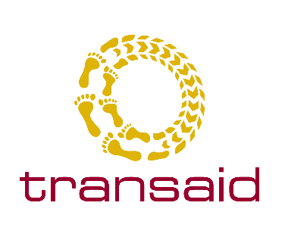
ARTICLE (4 minute read)
How MAM@Scale adapted to tackle COVID-19 whilst maintaining momentum in the fight against malaria
2020 marked the start of the Decade of Action on Sustainable Development, which aims to accelerate progress towards achieving the UN Sustainable Development Goals by 2030. However, this year also saw the emergence of a new coronavirus disease, COVID-19, which has had devastating effects on health systems globally and has the potential to put a halt to much of the progress made against specific Goals. This global pandemic also poses a serious threat to the broader social, economic, and political security of entire populations worldwide, disproportionately impacting communities in low-income countries and resource-constrained settings.
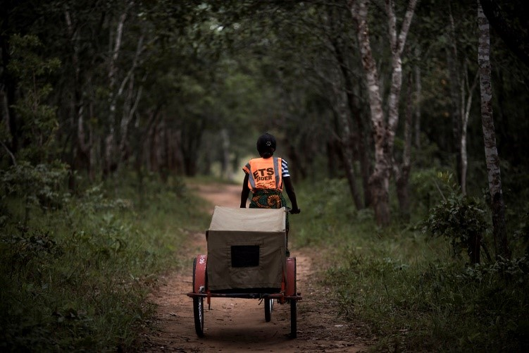
Picture 1. Community Health Volunteer (CHV) and Emergency Transport Scheme (ETS) rider Rabbecca riding a bicycle ambulance.

Lessons learned from the Ebola Virus Disease outbreak: the fight must continue against other public health challenges and threats
Disease modelling reports published earlier this year by the World Health Organisation (WHO) have suggested that COVID-19 could lead to significant setbacks in the fight against malaria. Disruptions to key activities such as insecticide-treated net distribution, essential medicine supply chains as well as health facility and community-based interventions could lead to a doubling in malaria mortality figures across Africa, with children under five and other vulnerable groups such as pregnant women bearing the highest burden.
Whilst these are unprecedented times, there are valuable lessons to be learned from the recent experiences of combatting malaria during the Ebola outbreak in West Africa, where disruptions to health service delivery led to a dramatic increase in malaria infections and deaths. These experiences teach us that whilst it is crucial to address the current needs of communities to stop the spread of COVID-19, it is also imperative that the existing structures that enable effective care giving and allow health care seeking are protected. Implementing responses which prioritise the adoption of integrated community case management (iCCM) of childhood illnesses, malaria and maternal health, for example, is fundamental to ensuring that communities continue to have access to essential public health services and health commodities, such as vaccines.

Background to MAM@Scale – tackling severe malaria in rural Zambia

Since December 2018, Transaid along with a consortium of partners including Development Data, DAI Global Health, Disacare and Medicines for Malaria Venture (MMV), has been working in partnership with Zambia's National Malaria Elimination Centre (NMEC), the Ministry of Health and District Health Management Teams (DHMTs) to deliver a lifesaving malaria intervention. The programme, MAMaZ Against Malaria at Scale (MAM@Scale), is currently operating in five districts undertaken with the financial support of Grand Challenges Canada (GCC) and the Government of Canada, through Global Affairs Canada (GAC), and MMV. Aligned with both the severe malaria and child health agendas of the Zambian government, the programme encompasses key activities to build sustainable capacity for the effective case management of severe malaria at the community level.
This occurs through the training and mobilisation of Community Health Volunteers (CHVs); awareness raising targeted to whole communities with strong emphasis on male involvement; and supporting the procurement and distribution of WHO quality assured pre-referral Artesunate Rectal Capsules (ARC) by the Ministry of Health. A community-managed Emergency Transport System (ETS) employing bicycle ambulances has also been established to strengthen community response and support timely referrals to the primary health care level. MAM@Scale thus aims to create sustainable capacity within Zambia for managing severe malaria at a community and health facility level and support the process of detailing a roadmap for wider national scale-up.

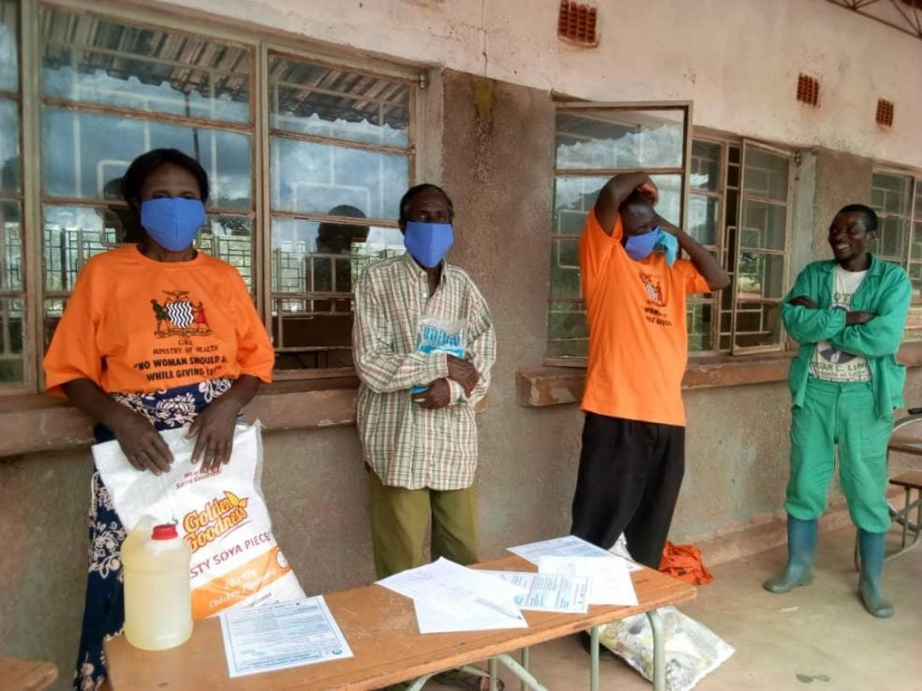
Picture 2. Community Health Volunteers (CHVs) receive food bank top-ups to help the most vulnerable families during the pandemic.

"MAM@Scale has done a great service to Chitambo, in July 2020 two riders transported a maternal emergency from Kamanga Community to Reuben Health Facility, which is a very long distance of about 30 kilometres. They did that while observing all procedures in preventing any possible spread of COVID-19, such as wearing masks, keeping a social distance, wearing of gloves when carrying the patient and regular washing of hands with soap"
Dr. Phiri – Chitambo District Health Office
What is MAM@Scale now doing to combat malaria within a COVID-19 context?

In the wake of the pandemic, the MAM@Scale programme had to quickly and effectively adapt in order to tackle the spread of COVID-19 while continuing the fight against severe malaria as well as other lifesaving work to enhance maternal health outcomes. Thanks to funding from the FIA Foundation for the Automobile and Society, together with Grand Challenges Canada and MMV, we were able to integrate COVID-19 prevention into our work and support the government of Zambia’s COVID-19 response.
Integrating a COVID-19 response into existing programmes has to be carefully tailored to the context in which we operate, although there are commonalities in the strategies that are put in place across countries. In broad terms, in order to safeguard the current gains on curtailing malaria deaths, it is crucial to disseminate appropriate information, address mobility and logistical constraints in maintaining health care and essential medicines supply chains, and protect health workers and patients alike.
A key element of the first response involved supporting the Zambian Ministry of Health through the Zambia National Public Health Institute (ZNPHI) to develop a set of COVID-19 guidelines for community health workers by contributing to on the role of CHVs in the context of COVID-19. Substantive, strategic inputs were also made to WHO and UNICEF COVID-19 community engagement guidelines (see here). Community Health Volunteers, who make up the backbone of the health system in rural Zambia, are a vital part of the MAM@Scale programme. As CHVs are a trusted voice in their communities, the
MAM@Scale team has orientated Community Facilitators on the danger signs and revised protocols around ETS and ARC, who have in turn trained CHVs to mobilise communities, and create a link between communities and health facilities. Key messages have been shared with CHVs, which has helped spread awareness to a population of over 300,000 people along with other targeted communications such as radio spots.

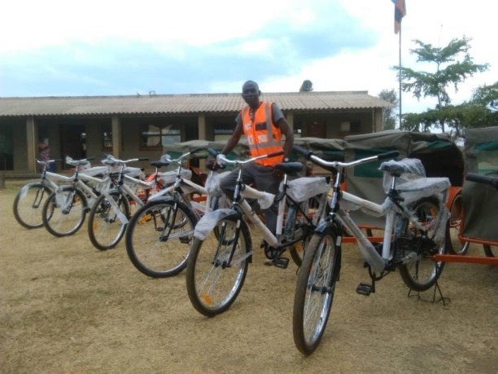
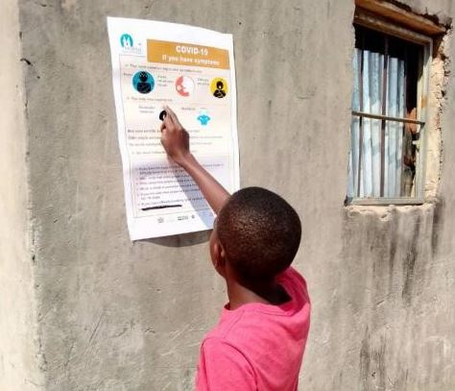
Picture 3. MAM@Scale’s Bernard Mpande with a fleet of bicycle ambulances. Training with added COVID-19 protective measures was rolled out in November 2020 in partnership with the USAID funded PAMO programme.
Picture 4. A poster outlining the signs and symptoms of COVID-19, displayed outside a health facility as part of MAM@Scale’s COVID-19 response.

To ensure that these potentially life-saving messages reach even the most remote areas, we are using a variety of channels to sensitise communities, including posters in four languages. We are also relying on a public address system for visits to rural communities to advise of the new guidelines, as well as utilising community radio to raise awareness through announcements, jingles, and even live broadcasts with phone-in discussions. In the most remote areas, CHVs are carrying out door-to-door visits, following social distancing protocols, to ensure that the message is communicated as widely as possible.
We have revised existing protocols for CHVs and bicycle ambulance riders so that they can easily adapt their activities to reduce the potential spread of COVID-19 and protect themselves. Both of these groups have undergone training to assimilate these new guidelines and protocols, and have been provided with personal protective equipment (PPE) such as cloth masks, gloves, and soap.
In rural areas where handwashing facilities are limited, new ‘tippy tap’ systems have been set up. Bicycle ambulances are now being washed by riders or health facility staff in between uses to minimise the risk of COVID-19 transmission, in line with the new safety protocols developed.
Finally, it is important to recognise that the barriers to healthcare in rural Zambia are not just physical. Often, visits to a health facility mean days spent away from home. For a subsistence farmer in a remote community, the costs involved in such a trip might be prohibitive. To ease the financial burden that the pandemic is placing on families, food banks that had been set up for families affected by severe malaria and maternal health challenges in communities served by MAM@Scale, are being expanded to help those impacted by COVID-19.

Sherrard-Smith E, Hogan A, Hamlet A et al. The potential public health impact of COVID-19 on malaria in Africa. Imperial College London (01-05-2020), doi: https://doi.org/10.25561/78668.
Parpia AS, Ndeffo Mbah ML, Wenzel NS, Galvani AP (2016). Effects of response to the 2014–2015 Ebola outbreak on deaths from malaria, HIV, and tuberculosis, West Africa. Emerg Infect Dis. http://dx.doi.org/10.3201/eid2203.150977

