Online Event Booking - Non-Member Journey

First locate the event you would like to attend via our website www.ciltuk.org.uk

Then click on the “Book Now” icon (top right-hand side of the event page):

If you are already logged in you will be taken straight to the Booker Information page where you can complete your details and book your place.

If you are not already logged in you will be taken to our log in page below:

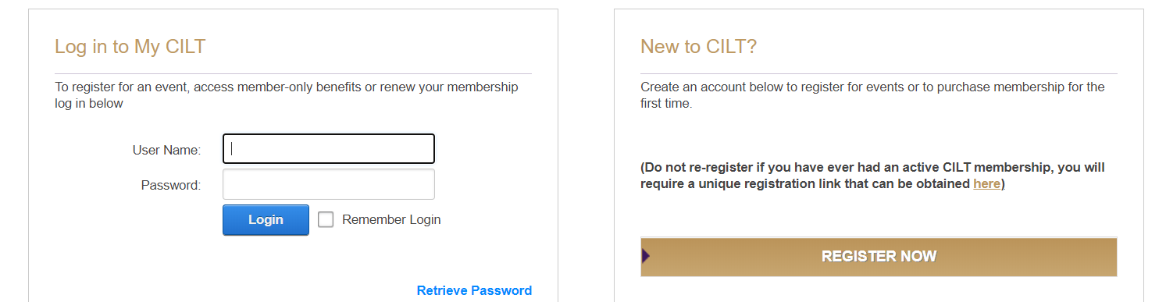

If you have already registered on our website as a Non-Member, you can log in using your usual details, and you will then be taken to the Booker Information page.

If you have not registered on our website before, please click on “Register Now” in order to do this. Once complete this will then take you to our home page.

To continue your booking, locate your chosen event on our website, then click Book Now and you will be taken to the Booker Information page where you can complete your details and book your place.

-End-

